

Comakership 1 + 2

Comakership A

Client: Erich van den Heuvel

Project Manager: Pepijn de Vries

Functional Design



Datum: 22/12/2011 Version: 1.0

# Configuration page

## Document entries

|  |  |  |  |  |
| --- | --- | --- | --- | --- |
| Version | Date | Status | Distribution | Author(s) |
| 0.1 | 15-9-2011 | Added:  - Lay-Out  - Cover  - Configuration page  - Chapter Structure  - Templates per chapter |  | RFL |
| 0.2 | 20-9-2011 | Added:  -20 Requirements |  | RFL |
| 0.3 | 27-9-2011 | Added and modified:  -10 Requirements  -Use case templates profiles, core , CMS |  | RFL, PKL, PVR |
| 0.4 | 13-10-2011 | Added and modified:  -Requirements  -Translation NL -> EN |  | RFL |
| 0.5 | 2 -11-2011 | Added:  -Scenario’s |  | RFL |
| 0.6 | 22-11-2011 | Changed:  - Functional requirements after feedback Erich |  | PVR |
| 0.7 | 1-12-2011 | Added:  -Interface structure  - Use case, Activity, Domain class diagrams |  | RFL, PVR |
| 0.8 | 8-12-2011 | Added:  -Prototype  -Design  -Justification design |  | PKL |
| 0.9 | 13-12-2011 | Added:  4 use case templates  Changed:  Requirements list final update + sortation.  Updated use case templates |  | RFL |
| 1.0 | 22-12-2011 | Final document check  Added:  -Introduction for each chapter  Changed:  -Sortation of use case templates  - Minor visual details in diagrams |  | RFL |

*Tabel 0.1: Document entries*

## Distribution management

|  |  |  |  |  |  |  |
| --- | --- | --- | --- | --- | --- | --- |
| Documentname | Type | Version Nr. | Sent to | Date | Return date | Status |
| Functional Design | Digital / Hard-copy | 1.0 | IIE, ASG | 22-12-2011 |  | Delivered |

*Tabel 0.2: Distibution management*

## Source documentation

|  |  |  |  |  |  |
| --- | --- | --- | --- | --- | --- |
| Documentname/title | Type | Version Nr. | Publisher / Author | Datum | ISBN / Codering |
| Research report | Digital / Hard-copy | 1.0 | Pepijn de vries | Later to be specified | NA |

*Tabel 0.3: Source documentation*

## Client

|  |  |  |  |
| --- | --- | --- | --- |
| Organisation | Adress | Postal Code | City |
| ASG | **Louis Armstrongweg 120** | **1311 RL** | Almere |

|  |  |  |  |  |  |
| --- | --- | --- | --- | --- | --- |
| Title | Name | Initials | Mobile | Email | Job function |
| Dhr | Heuvel, van de | E. | 0683177785 | [e.vandenheuvel@asg-almere.nl](mailto:e.vandenheuvel@asg-almere.nl) | Consultant informationmanagement |
|  |  |  |  |  |  |
|  |  |  |  |  |  |

*Tabel 0.4: Information Contracter*

## Project manager

|  |  |  |  |
| --- | --- | --- | --- |
| Organisation | Adress | Postal Code | City |
| IE Windesheim Flevoland | **Hospitaaldreef 5** | **1315 RC** | Almere |

|  |  |  |  |  |  |
| --- | --- | --- | --- | --- | --- |
| Title | Name | Initials | Mobile | Email | Job function |
| Dhr. | Kleef, van | P.M. | 0621214150 | Peter.van.Kleef@windesheimflevoland.nl | Specialist |
| Dhr. | Vries, de | P.T. | 0610560456 | Pepijn.de.Vries@windesheimflevoland.nl | Projectmanager |
| Dhr. | Floris | R.E.A | 0612394428 | Richard.Floris@windesheimflevoland.nl | Hoofdontwerper |

*Tabel 0.5: Information Projectmanager*

## 

## 

## For approval

|  |  |
| --- | --- |
| When this management document has officially been approved and signed by the client and the contractor it is to be considered authorized. The progress regarding this project is based on the specifications recorded in this document. The contents of this document are confidential. Therefore no part of this publication may be published or distributed without the express written consent of the client. | |
| Name client: dhr. E. van den Heuvel | Name contractor: Dhr. P.T. de Vries |
| Place/ date: | Place/ date: |
| Signature: | Signature: |

*Table 0.6: Approval*

Index

Configuration page 1

1 Introduction 5

2 Business Case 6

3 Requirements list 7

3.1 Functional requirements 7

3.1.1 Actors 7

3.1.2 Packages/Modules 7

3.2 Non-Functional requirements 12

3.3 Pseudo requirements 15

4 Use case scenarios 16

4.1 Front end 16

4.2 Back end 20

5 Use case diagram & templates 24

5.1 Must Have 24

5.1.1 Core 24

5.1.2 Profile 26

5.1.3 CMS 29

5.2 Should/Could/Would Have 33

5.2.1 Core 33

5.2.2 Profile 36

5.2.3 CMS 39

6 Activity Diagram 42

6.1 Must Have 43

6.1.1 Update school information 43

6.1.2 Compare 44

6.1.3 Comparison by list/tiles 45

6.1.4 Comparison by map 46

6.1.5 Manage comparison 47

6.1.6 Info Function 48

6.2 Should/Could/Would Have 49

6.2.1 Newsletter 49

6.2.2 Rating system 50

6.2.4 Flagging 51

7 Domain Class Diagram 52

7.1 Must Have 52

7.2 Should/Could/Would Have 53

8 Interface structure 54

8.1 Front End 54

8.2 Back End 54

9 Prototype 55

9.1 Front End 55

9.2 Back End 71

10 Graphic design details 82

10.1 Front end typography 82

10.2 Front end color 83

10.3 Front end layout 85

10.4 Front end hyperlinks 87

10.5 Back end typography 88

10.6 Back end color 90

10.7 Back end layout 92

Sources 93

Literature 93

Methods 93

# 1 Introduction

This document will provide a thorough understanding of the functionality and design to the reader regarding the upcoming application for the project “SchoolInzicht”. Certain basic skills and basic knowledge are required to comprehend the content contained in this document.

* Programming language
* Comprehension of databases
* Comprehension of UML(Unified Modeling Language) methods

Before reading this document, the reader should keep in mind that this document is quite elaborate. This is due to a request from the client wanting to implement possibly all of the given ideas after our project has been completed. This document combined with the technical design, will make it possible for any decent programmer to find anything he would need technically en functional-wise regarding the application. Thus he would be able to implement existing ideas into the system and modify these if the need arises with ease.

The decision was made to split the majority of the UML into the following sections:

* Must haves
* Should/Could/Would haves

The “must haves” represent the sections of the application that we as a group will be implementing ourselves and will form the basic application. The “should/could/would haves” represent the sections of the application that can be implemented at any given time after the project is finished. This decision was made so the client can easily see what we will develop and what can be developed afterwards.

To conclude the introduction, focus wise we chose to elaborate on mainly 2 things regarding UML:

* What the main focus of the client is.
* What is somewhat unique and needed to be clarified

The use case scenarios do not entirely match granularity wise with the diagrams that follow after the scenarios. This was mainly because we focused on the sections of the application that were commonly used in other applications and only needed a minimum amount of explanation in the scenarios together with the client’s focus and elaborated on the unique/not often used sections of the system in activity diagrams. This was an attempt to somewhat limit the size of the entire document but still describe every section of the system thoroughly.

# 2 Business Case

This business case is part of project “InSight” or “Schoolinzicht” (work titles).

There is a project plan as well as an underlying research document that can clarify the establishment of some ideas and choices in this document.  
This business case gives some insight in the background and cause of this project.

The motivation for this project unofficially started on 16 December 2010 when the political movement VVD asked the school boards to improve the transparency of elementary school quality, ASG took the initiative to come up with an idea. In May 2011 Erich van den Heuvel contacted Windesheim Flevoland and asked for students who could make an application to fulfill this need of information insight.

ASG is one of the three biggest school boards of Almere. They manage 51 elementary schools, and is bigger than the two other boards, Prisma and SKOFV. This project is initiated by ASG, but developed in participation with Prisma and SKOFV. In the future the application should be managed by all the boards.  
  
The biggest challenge for ASG is to put school results into context. It is our job to make a website that facilitates both results and the context in an attractive and user-friendly way.

The only way to get access to school quality information nowadays is by visiting the government website and download an overview of the inspection reports or trust the schools / neighbors or friends to provide valid information.  
We are creating a digital place where parents can check if this information is true and what it actually means for that particular school.

The chosen form for this concept is a comparison website. Parents will be able to make a comparison between schools filtered on e.g. distance from home, size and school type. They can sort schools, look at them side by side and see all the quality (school performance results) information and context.

This functional design describes all possible functions and is necessary to program the final website. Agreeing with this product will authorize us to start the building phase where a technical design and working prototype with all “must-have requirements” will be delivered. Given enough time we will also incorporate should/could/would haves after consulting with the client.

# 3 Requirements list

The requirements list will summarize and illustrate the functions, non-functional components and constraints regarding the website, accordingly, this chapter is divided in the paragraphs: “Functional”, “Non-functional” and “Pseudo”. This will be the core of the document and all the upcoming chapters will work out certain requirements in detail.

## 3.1 Functional requirements

## 3.1.1 Actors

* Visitor (V) (The primary user of the application which shall be mostly composed out of parents/guardians.)
* School (Sch)
* Admin (A)(H,L) (High level, Low level)
* Database (DB)

*The Database is an actor for every requirement unless specified otherwise. This will be done so by putting a   
“-“character at the actor column*

*Manage is defined as being able to “View, Modify, Add, Remove” the defined content.*

## 3.1.2 Packages/Modules

* Core Application(K)
* School Profiles (P)
* Content Management (CMS)

|  |  |  |  |  |  |
| --- | --- | --- | --- | --- | --- |
| ID | Requirement | Description | Package | Actor | Priority (MSCW) |
| 1.1 | Login (CMS) | The admin can log in to gain access to the CMS with the use of a username and password. User has the ability to log out. The User will be automatically logged out after 15 min of inactivity. | CMS | A(H,L) | M |
| 1.2 | Retrieve password (CMS) | Admin is able to retrieve password by choosing the “forgot password” option after which their password is sent to their email | CMS | A(H,L) | M |
| 1.3 | Retrieve password (CMS) | Admin is able to retrieve password by choosing the “forgot password” option after which their password is sent to their email | CMS | A(H,L) | M |
| 1.4 | Manage schools | The admin is able manage schools on the CMS. | CMS | A(L) | M |
| 1.5 | Upload .CSV | Load in new school performance results (with the use of a .CSV file) into the database by selecting the correct file and upload this to the website. | CMS | A(L) | M |
| 1.6 | Manage front-end articles | The admin is able to manage the front-end articles. | CMS | A(H) | M |
| 1.7 | Search/Compare Schools | Search/Compare schools by filling in the desired criteria and selecting the desired sortation value. | P | V | M |
| 1.8 | School selection view: list | View and select the desired filtered schools from a list view. | P | V | M |
| 1.9 | Link to school | Redirection to the selected school’s website in a new tab. | P | V | M |
| 1.10 | School selection view: map | View and select the desired filtered schools from a map view. | P | V | M |
| 1.11 | Update school information | By filling in a web form containing : “*School name”, “School code”, “Type of education”, “Address”, “Postal Code”, “Website”, “Email”, “Mission” and “Vision”. A school is able to update its global information on the website.* | P | Sch | M |
| 1.12 | Graph generator | Generate and view school performance results in graphs. | P | DB | M |
| 1.13 | Save in PDF | The user saves the desired school performance results tab or global school information from the selected school in a PDF format. | P | V | M |

|  |  |  |  |  |  |
| --- | --- | --- | --- | --- | --- |
| 1.14 | Adjustable criteria comparison | All criteria selected for the use case “comparison” must be editable throughout all the steps of the use case/process aside from viewing one profile. | P | V | M |
| 1.15 | Adjustable selection  Comparison | School must be removable and addable throughout all the steps of the use case/process aside from viewing one profile. | P | V | M |
| 1.16 | Anti-Duplicates | Certain attributes (Login, Login – email, article names, school - Email address, newsletter – Email address) cannot exist multiple times in the database and will be checked at interactions | K | S | M |
| 1.17 | Syntax Checker | Certain fields (BRIN number, email extensions, school website URL extensions) will be checked according to corresponding fields. | K | V | M |
| 1.18 | Info Function | The user is able to get information regarding criteria and help on how to operate the website | K | V | M |
| 1.19 | Project-credits | A page dedicated to the developers of the project. Containing their *“names”, “functions” and “Email”* | K | V,C | M |
| 1.20 | Contact Page | Page with global contact information regarding the website administration | K | V | M |
| 1.21 | Flagging | Admins are able to flag items for which they don’t have permissions to directly change it with comments that can be filled in. This in order for admins that do have permission being able to change the items if they deem it appropriate. A maximum of 5 comments per flagged article is allowed. | CMS | A(L,H) | S |
| 1.22 | School selection view: tiles | View and select the desired filtered schools from a tiles view. | P | V | S |
| 1.23 | Link social media | Press the “*I like*” button at the selected school profile page or comparison. This will allow users to like and share content on *social media sites. A minimum of Twitter and Facebook will be needed*. | P | V | S |
| 1.24 | Buttons – grayed out | Buttons that are not available for use because certain criteria might not be fulfilled, will be grayed out until the criteria are fulfilled. | K | M | S |
| 1.25 | Manage users | Admins is able to manage users in the CMS. | CMS | A(H) | C |
| 1.26 | Send newsletter | The admin can send an automatically generated (modifiable) email containing an update message regarding the new content placed on the website for the users signed up for the newsletter. | CMS | A | C |
| 1.27 | Register newsletter | Sign up for the update newsletter by filling in the users own *email address*. | P | V | C |
| 1.28 | Mail school performance results | Mailing the selected school performance results to the desired email address. | P | V | C |
| 1.29 | Recommended Search | The terms that users often use in the search engine. | K | V | C |
| 1.30 | Recent Search | The terms the user recently used in the search engine. | K | V | C |
| 1.31 | Un-register newsletter | Un-registers by filling in your “email address” and confirming this action by following the link sent to your email address. | K | V | C |
| 1.32 | Search Function | Search a school directly by filling in the school name in the search engine. | K | V | C |
| 1.33 | FAQ | Frequently Asked Questions regarding the website. | K | V | C |
| 1.34 | Contact Form | Contact the website admin through a web form after filling in the users own *email address*, *name* and the *content* of the *message* | K | V | C |
| 1.35 | Frames | Schools can integrate their profiles into their own website with the use of frames. | P | V | W |
| 1.36 | Rating system | Users are able to fill in a survey regarding a particular school which in turn gives the school an average grade viewable by the users. | P | V | W |
| 1.37 | Change font | Change font-size scale to the desired scale on the entire website. | K | V | W |
| 1.38 | Choose Language | The user can select the desired language the website will be viewed in. The core function so it can be used by uploading text files after the project is finished. Must be capable of switching at least between Dutch and English | K | V | W |

## 3.2 Non-Functional requirements

|  |  |  |  |  |
| --- | --- | --- | --- | --- |
| ID | Requirement | Description | Package | Priority (MSCW) |
| 2.1 | Website size (pixels) | The website can never be bigger that 1024 px (with scrollbar) to prevent problems with the smallest common resolution. | Accessibility | M |
| 2.2 | Short URL | The URL is as short as possible and will contain shortened details of the comparison, enabling the user to share their comparison. | Operation | M |
| 2.3 | Graph- multiple graph types | Graphs must be able to be created in at least 3 different graph types: “*Pie chart”, “Line graph”, “Bar graph”.* | Operation | M |
| 2.4 | Publish restrictions | Articles can only be published if all fields are filled in. | Operation | M |
| 2.5 | Graph - creatable in at least 3 unique colors | Every Graph must be able to be created in at least 3 colors (multiple shades of 1 color) and every comparison (max 3 diagrams) will need a minimum of 9 different colors to help users compare results from multiple schools. | Usability | M |
| 2.6 | Default selected | All default selected buttons/attributes will appear pressed or hovered on. | Usability | M |
| 2.7 | Info function maximum size. | The height of the info function may not be more than 250 px. | Usability | M |
| 2.8 | Info function maximum characters | The info function may not hold more than “1000” characters. (2 columns of 500, enough place for 3 paragraph breaks in a 250px bar with font size 12.) | Usability | M |
| 2.9 | Search engine maximum hits per page | Maximum of 50 hits/results per page regarding the search engine. | Usability | M |
| 2.10 | Clickable items – 90% blue | 90% of the clickable items must be blue to assist the user in navigating on the website | Usability | M |
| 2.11 | Extra tabs | At a school profile the admin is able to create at least 1 tab row with a maximum of 3 rows to separate information. | Implementation | M |
| 2.12 | Graph - scalable | Graphs need to be scalable so they can be enlarged once selected. | Operation | S |
| 2.13 | Mouse over menu | All options will be displayed and dropped down when the mouse hovers over the menu. | Usability | S |
| 2.14 | New Tab | Saving a PDF and opening a school website will always open in a new tab | Usability | S |
| 2.15 | Mouse over menu | All options will be displayed and dropped down when the mouse hovers over the menu. | Usability | S |
| 2.16 | Picture format | All pictures will be restricted to a .JPG extension. | Implementation | S |
| 2.17 | Comparison + profile restriction social media | Social media links will only be available on the comparison page and the school profile page. | Implementation | S |
| 2.18 | Browser log-out | After shutting down the browser the session closes and the user will be logged out automatically. | Security | S |
| 2.19 | Password restrictions | Passwords must contain at least 1 number, 1 capital letter and a minimum of 6 characters. | Security | S |
| 2.20 | Picture/logo size | Pictures or logos maximum size is 200 px width x 100 px height. | Usability | W |
| 2.21 | Clicks | Every page needs to be reachable within ‘5’ clicks. (excluding the criteria and school selection clicks) | Usability | W |
| 2.22 | List – items grayed out until hover | Clickable items in a list can be 50% transparent until the mouse hovers on the desired item or until it is selected. | Usability | W |
| 2.23 | Font size minimum and maximum | Font size minimum of 8px and a maximum of 24px. | Usability | W |
| 2.24 | Frames minimum size | Frames must have a minimum size of width : 768 pixels by height: 418 pixels | Usability | W |
| 2.25 | Clickable frames | Frames will be clickable so users can easily be forwarded to the page on our website. | Usability | W |
| 2.26 | Rating system, Sources shown | Sources regarding how many users have filled in the surveys and what information they filled in will be viewable at the rating. | Implementation | W |
| 2.27 | Rating shown with at least 25 user surveys. | Ratings will not be shown unless 25 surveys have been filled in to get accurate averages from the selected school. | Implementation | W |
| 2.28 | Loading time | The website loading time may not be longer than 3 seconds due to size. (Server and internet connection are separate factors) | Performance | W |

## 3.3 Pseudo requirements

|  |  |  |  |
| --- | --- | --- | --- |
| ID | Requirement | Description | Package |
| 3.1 | Information extension | School information will be delivered as a .CSV file | Implementation |
| 3.2 | Database extension | MySQL database | Implementation |
| 3.3 | Programming code | The used program languages will be: *PHP, JAVASCRIPT, HTML* en  *CSS* | Implementation |
| 3.4 | Inline Documentation | There will be notes and descriptions in the code wherever needed. | Implementation |
| 3.5 | All text from database | The use of articles which will be stored in the database for all texts on the front end. | Implementation |
| 3.6 | Mail Server - SMTP | The functions that will send mails will use a SMTP protocol and will require a mail server. | Implementation |
| 3.7 | POP 3 / IMAP | The functions that receive mails will use a POP 3 or IMAP protocol and will require a mail server. | Implementation |
| 3.8 | Server - Linux | The server will run on a Linux platform. | Implementation |
| 3.9 | CSV. Name | The CSV file names have to equal to pre-defined names, to rule out errors. | Security |

# 4 Use case scenarios

The use case scenario chapter contains requirements that were important for this project and either needed to be worked out in scenarios and activity diagrams(due to being unique and important to the project) or just scenarios (due to the requirement being commonly known). These are split into front end and back end (CMS) sections.

*Alternative and branching routes during a use case scenario are specified by using A., B., C. Etc. followed by the flow of each route.*

## 4.1 Front end

|  |  |
| --- | --- |
| Goal | Updating/adding the school. |
| Actor | School |
| Rights | Readable and modifiable (web form content) |
| Trigger | New school or outdated information. |
| Scenario  (Succesvol) | 1. The school visits the website 2. The school hovers above the “contact” menu button. 3. The menu button expands, displaying : “address information (from the different school boards)”, “Contact admin”, “for schools” 4. The School selects the “for schools” section 5. The website loads a web form containing *“School name”, “School code”, “Education type”, “Address”, “Postal code”, “Website URL”, “Email”, “Mission” and “Vision” and tabs later to be determined*. 6. The School fills in the previously stated information and presses the send button. 7. The system authenticates the “School code and email extension”. 8. The system loads a confirmation window stating that the request has been sent and that the school will receive an email to verify the authenticity of the request and school. Once the email has not been received within 10 min to check the spam folder and contact the admin. 9. The School confirms the confirmation screen and awaits the email. 10. The system sends a mail containing text to illustrate the purpose of the email and a link. 11. The School clicks the link and is forwarded to a content confirmation screen. 12. The system loads the content confirmation screen containing all the previously filled in information with the option of confirming the request or cancelling the request. 13. The School clicks on the “confirm” button. 14. The System loads another confirmation window stating that the school has sent the request and that it will take “x” amount of days for the request to be processed. 15. The system sends a mail to the admin. 16. The admin approved the request. 17. The System sends a mail to the school notifying that the request has been approved and the school should be online within “x” hours.   -End of Flow- |
| Scenario  (unsuccessful) | 1. The school visits the website 2. The school hovers above the “contact” menu button. 3. The menu button expands, displaying : “address information (from the different school boards)”, “Contact admin”, “for schools” 4. The School selects the “for schools” section   *(Continues on the next page)*   1. The website loads a web form containing *“School name”, “School code”, “Education type”, “Address”, “Postal code”, “Website URL”, “Email”, “Mission” and “Vision” and tabs later to be determined*. 2. The School fills in the previously stated information and presses the send button. 3. The system authenticates the “School code”.    1. The system finds the school code invalid.       1. The system loads a notification that the school code appears to be invalid 4. School fills in the incorrect school code 4 times    1. The form is locked for 15 min for this IP   –End of flow-   1. School fills in the correct “school code”. 2. Proceed with flow at 7B    1. The system finds the “school code” valid. Proceed with flow at 8. 3. The system loads a confirmation window stating that the request has been sent and that the school will receive an email to verify the authenticity of the request and school. Once the email has not been received within 10 minutes to check the spam folder and contact the admin. 4. The School confirms the confirmation screen and awaits the email. 5. The system sends a mail containing text to illustrate the purpose of the email and a link. 6. The school does not receive an email containing the link. 7. The School visits the website and clicks the “contact admin” submenu”. 8. The System loads the form. 9. The School fills in the “Title”, “Problem description” and “Email” and sends the contact request. 10. Once viewed and validated by the admin, the admin will notify the school and the process will continue as normal at scenario: “Handling a school update/add request”. 11. The school has received the email – Proceed with flow at 11. 12. The School clicks the link and is forwarded to a content confirmation screen. 13. The system loads the content confirmation screen containing all the previously filled in information with the option of confirming the request or cancelling the request. 14. The School clicks on the “confirm” button. 15. The System loads another confirmation window stating that the school has sent the request and that it will take “x” amount of days for the request to be processed. 16. The admin denied the request 17. The System sends a mail to the school notifying that the request has been denied.   -End of Flow- |

|  |  |
| --- | --- |
| Goal | Comparing Schools |
| Actor | Visitor |
| Rights | Readable, Selectable |
| Trigger | Parent visited the schools and wants to compare them statistically |
| Scenario  (Successful) | 1. The visitor visits the website 2. The visitor views the homepage with the frame search school. 3. The visitor selects the desired criteria for his comparison between “distance”, “number of students”, “type of education” and selects the “compare by list” or the “Compare by map” button. 4. The system loads a list of schools adjusted by the selected criteria with “distance”, “number of students”, “type of education”. 5. The visitor selects 3 schools from the list for comparison. 6. The system loads an overview of the 3 school with global school information. 7. The visitor selects the “enlarge button” on one of the schools. 8. The system retrieves and loads all the information and school performance results in graphs. 9. The visitor selects the 2nd tab of information with “students” information. 10. The system loads the graphs. 11. The visitor selects the “minimize school” or the “return” button. And has been put back to the overview of 3 schools. 12. The visitor selects the “compare” button. 13. The system retrieves and loads all the different school performance results in graphs. 14. The visitor clicks on one of the graphs. 15. The system loads a new screen with the enlarged graph. 16. The visitor deselects one school next to the graph. 17. The system adjusts the graph accordingly. 18. The visitor selects the pie chart option. 19. The system adjusts the graph accordingly.   –End of Flow - |
| Scenario  (unsuccessful) | 1. The visitor visits the website 2. The visitor views the homepage with the frame search school. 3. The visitor selects the desired criteria for his comparison between “distance”, “number of students”, “type of education” and selects the “compare by list” or the “Compare by map” button. 4. The system loads a list of schools adjusted by the selected criteria with “distance”, “number of students”, “type of education”. 5. The visitor views the list for comparison.    1. The visitor has selected over “y” amount of schools.       1. The system sends a warning that you can only compare with a maximum of “3” schools.       2. The visitor adjusts the selection accordingly and presses the “compare” button.       3. Proceed with flow at 7. 6. The visitor selects 3 schools. 7. The system loads an overview of the 3 schools with global school information.   *(Continues on the next page)*   1. The visitor selects the “enlarge button” on one of the schools.    1. The system retrieves and loads all the information and school performance results in graphs.       1. The visitor selects the 2nd tab of information with “students” information.       2. The system loads the graphs.       3. Proceed with flow at 9.    2. The system retrieves the school information and tries to retrieve the school performance results in graphs. However, school performance results are non-existent.       1. The system loads the school information and loads empty graphs with a text saying: “school performance results are not updated”.       2. Proceed with flow at 9. 2. The visitor selects the “minimize school” or the “return” button. And has been put back to the overview of 3 schools. 3. The visitor selects the “compare” button.    1. The system retrieves and loads all the different school performance results in graphs.       1. Proceed with flow at 11.    2. The system is unable to load the performance results of one of the selected schools.       1. The system loads the graph of the remaining schools with a text at the bottom that a portion of the selected schools are not viewable in graphs due to the lack of school performance results.       2. Proceed with flow at 11. 4. The visitor clicks on one of the graphs. 5. The system loads a new screen with the enlarged graph. 6. The visitor deselects one school next to the graph. 7. The system adjusts the graph accordingly. 8. The visitor selects the pie chart option. 9. The system sends back a message that the desired chart is not available due to lack of data and/or lack of that option being disabled depended on the type of data it should be portraying.   –End of Flow - |

## 4.2 Back end

|  |  |
| --- | --- |
| Goal | Handling a school update/add request. |
| Actor | Admin |
| Rights | Viewable, Editable, Removable, Addable , Modifiable |
| Trigger | Sent in request by a school. |
| Scenario  (Successful) | 1. The System sends a mail to the admin containing a message stating that a new school update/add request has been sent in with an URL linking to the request list at the back-end. 2. The Admin clicks on the link and fills in his username and password to login. 3. The System authenticates the username and password. 4. The System finds the information valid. 5. The System loads the request list. 6. The Admin is logged in and viewing the request list with new requests. 7. The Admin selects the desired request. 8. The System loads the filled in request web form containing *“School name”, “BRIN”, “Education type”, “Address”, “Postal code”, “Website URL”, “Email”, “Mission” and “Vision”, “Context per graph”*. 9. The Admin views the content. 10. The Admin selects the correct performance results .CSV file. 11. The Admin finds the content valid and presses the “confirm” button. 12. The system loads a confirmation screen requesting another confirmation from the admin. 13. The Admin confirms the confirmation screen. 14. The System adds/updates the school information. 15. The system sends a confirmation mail to the school in question. |
| Scenario  (Unsuccessful) | 1. The System sends a mail to the admin containing a message stating that a new school update/add request has been sent in with an URL linking to the request list at the back-end. 2. The Admin clicks on the link and fills in his username and password to login. 3. The System authenticates the username and password.    1. The System finds the information invalid.       1. The Admin fills in a different set of information 3 times.       2. The System blocks the IP for 15 minutes.   End of flow   * 1. The System finds the information valid.      1. Proceed with flow at 4.  1. The System loads the request list. 2. The Admin is logged in and viewing the request list with new requests.    1. Request list is empty due to another admin already handling the new requests.       1. The Admin selects the “Handled request list” tab to double check.       2. The System loads the handled request list tab.       3. The Admin finds the request already properly handled.   End of flow   1. The Admin selects the desired request. 2. The System loads the filled in request web form containing *“School name”, “BRIN”, “Education type”, “Address”, “Postal code”, “Website URL”, “Email”, “Mission” and “Vision”, “Context per graph”*. 3. The Admin views the content. 4. The Admin selects the correct performance results .CSV file.    1. School performance results for the particular school do not yet exist or are not supplied yet.       1. The admin does not select a .CSV file but still judges the content.       2. Proceed with flow at 10. 5. The Admin finds the content invalid and presses the “deny” button. 6. The system loads a confirmation screen requesting another confirmation from the admin. 7. The Admin confirms the confirmation screen. 8. The System sends a confirmation mail to the school in question.   End of Flow |

|  |  |
| --- | --- |
| Goal | Updating the front-end articles |
| Actor | Admin |
| Rights | Readable, Removable, Addable, Modifiable |
| Trigger | New information available for the front-end |
| Scenario  (Successful) | 1. The admin visits the back-end URL. 2. The system loads a login screen 3. The admin fills in his username and password. 4. The system authenticates the username and password. 5. The system finds the information valid. 6. The system loads the back-end home containing a brief list of updates. 7. The admin selects the “front-end” articles menu. 8. The system loads the article list containing all existing front-end articles. 9. The admin selects the 4th article and the option modify. 10. The system loads the contents of the selected article containing “Article ID”, “Article Name”, “Content”, “Category”, ”Location”, “Publish”, “Info text”, “creation date”, “author”, “modify date”, “modify author”. 11. The admin edits the description, name and content. 12. The admin selects the “Save” button. 13. The system loads a confirmation window. 14. The admin confirms the confirmation request. 15. The system saves the modified information.   End of Flow |
| Scenario  (unsuccessful) | 1. The admin visits the back-end URL. 2. The system loads a login screen 3. The admin fills in his username and password. 4. The System authenticates the username and password.    1. The System finds the information invalid.       1. The Admin fills in a different set of information 3 times.       2. The System blocks the IP for 15 minutes.       3. After 15 min the system unblocks the IP.       4. The admin fills in the username and password.   Proceed with flow b   * 1. The System finds the information valid.      1. Proceed with flow at 5.  1. The system loads the back-end home containing a brief list of updates. 2. The admin selects the “front-end” articles menu. 3. The system loads the article list containing all existing front-end articles.    1. The admin selects the 4th article and the option modify.       1. The system loads the contents of the selected article containing “Article ID”, “Article Name”, “Content”, “Category”, ”Location”, “Publish”, “Info text”, “creation date”, “author”, “modify date”, “modify author”.       2. The admin edits the description, name and content.       3. The admin selects the “Save” button.       4. The system loads a window stating that the admin does not have enough permission to edit the selected article.   End of flow   * 1. The admin selects the 4th article and the option remove.      1. The system loads a window stating that the admin does not have enough permission to edit the selected article or that the article may only be editable.   End of flow   * 1. The admin selects the add article option.      1. The system loads a web form containing “Article ID”, “Article Name”, “Content”, “Category”, ”Location”, “Publish”, “Info text”, “creation date”, “author”, “modify date”, “modify author”.      2. The admin selects the desired category and fills in the information.      3. The admin selects the “Save” button.      4. The system loads a window stating that the admin does not have enough permission to add an article in the selected category.   End of flow |

|  |  |
| --- | --- |
| Goal | Updating school performance results |
| Actor | Admin |
| Rights | Viewable, Addable, Removable |
| Trigger | New school performance results are available |
| Scenario  (Successful) | 1. The admin visits the back-end URL. 2. The system loads a login screen 3. The admin fills in his username and password. 4. The system authenticates the username and password. 5. The system finds the information valid. 6. The system loads the back-end home containing a brief list of updates. 7. The admin selects the “Schools” button. 8. The system loads a list with all the schools added. 9. The admin selects the desired school. 10. The system loads the school with all the information. 11. The admin selects the “upload school results” button. 12. The admin selects the correct path of the file. 13. The admin presses the “save” button. 14. The system loads a confirmation window. 15. The admin confirms the confirmation request. 16. The system saves the modified information.   End of flow |
| Scenario  (unsuccessful) | 1. The admin visits the back-end URL. 2. The system loads a login screen 3. The admin fills in his username and password. 4. The System authenticates the username and password.    1. The System finds the information invalid.       1. The Admin fills in a different set of information 3 times.       2. The System blocks the IP for 15 minutes.       3. After 15 min the system unblocks the IP.       4. The admin fills in the username and password.   Proceed with flow b   * 1. The System finds the information valid.      1. Proceed with flow at 5.  1. The system loads the back-end home containing a brief list of updates. 2. The admin selects the “Schools” button. 3. The system loads a list with all the schools added. 4. The admin selects the desired school. 5. The system loads the school with all the information. 6. The admin selects the “upload school results” button. 7. The admin selects the correct path of the file. 8. The admin presses the “save” button. 9. The system loads a window stating that the school has been put on inactive and thus can’t have school performance results uploaded. 10. The admin selects the “Ok” button”. 11. The admin pressed on the “back” button. 12. The system loads the school overview list. 13. The admin presses on the inactive icon next to the school. 14. The system loads a window stating that the admin does not have enough permission to modify inactive/active states.   End of flow |

# 5 Use case diagram & templates

The use case diagrams and templates contain all the functional requirements worked out into diagrams and use case templates following each diagram. These are split into “must haves” and “should/could/would haves” and the selected packages.

## 5.1 Must Have

### 5.1.1 Core

Core contains the “must have” functional requirements from the core package, the core package are the general requirements on for website.



|  |  |
| --- | --- |
| Name | Syntax Checker |
| Actors | Visitor, School, Database |
| Description | Checks if syntax corresponds with available information |
| Flow of Events | 1. Visitor fills in his “email” 2. System checks if the email extensions correspond with those in the database. 3. Visitor views a validation or error. 4. School fills in his “email”, ”BRIN” and “school website” 5. System checks if the extensions correspond with those in the database. 6. School views a validation or error. |
| Preconditions | Must not already be checked |
| Post conditions | Filled in information is checked for validity |
| Exceptions |  |

|  |  |
| --- | --- |
| Name | View project credits |
| Actors | Visitor, Database |
| Description | Views information about the project developers and contributors. |
| Flow of Events | 1. Visitor selects the menu *“Contact”.* 2. Database retrieves the project credits from database. 3. Visitor views the page *“Contact”* containing the project credits. |
| Preconditions | Project credits must exist. |
| Post conditions | User has the information needed to contact the developers. |
| Exceptions |  |

|  |  |
| --- | --- |
| Name | View contact |
| Actors | Visitor, Database |
| Description | User views contact information regarding the application/admins. |
| Flow of Events | 1. Visitor selects the menu button *“Contact”.* 2. Database retrieves the information from the database. 3. Visitor views page *“Contact”* containing admin, creator and sponsor information. |
| Preconditions | Contact information must exist. |
| Post conditions | User has information needed to contact the admin. |
| Exceptions |  |

|  |  |
| --- | --- |
| Name | Info Function |
| Actors | Visitor, Database |
| Description | Visitor views information about unknown words of phrases. |
| Flow of Events | 1. Visitor clicks a site question mark symbol. 2. Database retrieves associated information from database. 3. The info section will expand if not already and show the associated text. |
| Preconditions | There is only a question mark symbol available when a info article is attached. |
| Post conditions | User can read extra information about certain subjects or words. |
| Exceptions |  |

### 5.1.2 Profile

The profile contains the “must have” functional requirements associated with the comparison and school profiles section on the website. This is the main focus for the project.



|  |  |
| --- | --- |
| Name | Adjustable selection |
| Actors | Visitor, Database |
| Description | Visitor is able to adjust his/her selection while comparing |
| Flow of Events | 1. Visitor removes the desired schools 2. Visitor selects the desired schools 3. Visitor selects the “compare” button. |
| Preconditions | Visitor is on the selection page (general overview with 3 schools next to each other)  Visitor has added at least 3 school to his/her selection |
| Post conditions | Visitor has modified his/her selection. |
| Exceptions |  |

|  |  |
| --- | --- |
| Name | Adjustable criteria |
| Actors | Visitor, Database |
| Description | Visitor is able to adjust his/her criteria while selecting |
| Flow of Events | 1. The visitor removes the desired criteria 2. The visitor adds the desired criteria 3. The visitor sees a updated overview matching his/her new criteria |
| Preconditions | Criteria cannot already be selected |
| Post conditions | Visitor views an updated view of schools. |
| Exceptions |  |

|  |  |
| --- | --- |
| Name | Comparison by map |
| Actors | Visitor, Database |
| Description | Visitor views schools by location on a map |
| Flow of Events | 1. Visitor fills in postal code. 2. Visitor chooses the “map” view 3. Visitor clicks the “compare” button 4. Visitor sees a (Google)map with pinpointed school locations. 5. Visitor can change his criteria or switch his view and is able to delete schools from the view or go back to the previous screen. 6. Visitor can select 2 or 3 schools and click the *“compare”* button. |
| Preconditions | Postal code must be filled in |
| Post conditions | Continue same as compare school profiles template from step 7. |
| Exceptions | Wrong postal code generates wrong or no results. |

|  |  |
| --- | --- |
| Name | Compare school profiles |
| Actors | Visitor, Database |
| Description | Visitor filters schools to compare them |
| Flow of Events | 1. Visitor chooses 0 or more criteria. 2. Visitor chooses a list view. 3. Visitor clicks the *“compare”* button. 4. Visitor will see all the schools within his criteria in the desired view. 5. Visitor can change his criteria, sorting options or switch his view and is able to delete schools from the view or go back to the previous screen. 6. Visitor can select 2 or 3 schools and again click the *“compare”* button. 7. Visitor will see 2 or 3 schools next to each other with more information than the previous windows. 8. Same as step 5. 9. Visitor can click “compare” again for his final comparison. |
| Preconditions | Visitor is on the home page |
| Post conditions | Visitor will see the selected schools beneath each other with multiple tabbed pages that hold categorized information. |
| Exceptions | When there is no *“view”* selected, the list view will be chosen when the “compare” button is being clicked.  When there is no postal code filled in, the *“map”* option is grayed out. |

|  |  |
| --- | --- |
| Name | Generate graphs |
| Actors | Visitor, Database |
| Description | The visitor visits a part of the website that contains data in graph form. |
| Flow of Events | 1. Visitor requests data that needs an explanatory graph. 2. The system reads the needed information from the database 3. An API generates the graphical content. 4. Visitor clicks on graph for an enlargement. |
| Preconditions | Data for graph generation must exist |
| Post conditions | Graphs are generated and shown on the desired page. |
| Exceptions |  |

|  |  |
| --- | --- |
| Name | View school profile |
| Actors | Visitor, Database |
| Description | Visitor views a school profile for more information about one particular school without a comparison. |
| Flow of Events | 1. Visitor clicks any school name, in any step of the comparing process. 2. Visitor views the school profile page containing global information and school performance results |
| Preconditions | Visitor completed step one of the comparison and has a school name on screen. |
| Post conditions | The visitor has more information regarding a school |
| Exceptions |  |

|  |  |
| --- | --- |
| Name | Request school information update |
| Actors | School, Database |
| Description | School fills in extra information for their school by using a form. |
| Flow of Events | 1. School clicks on the *“contact”* menu item and submenu *“school form”.* 2. School fills *“BRIN nr”* and *“E-mail address”* in. 3. School clicks the “verify” button. 4. School will get an error massage if either one is incorrect. (non-existing in the database) 5. If the combination is accepted, the last entered information is filled in in the form. 6. The school can edit and add information and send the from. 7. The form will be available for checking in back-end. 8. When the information is accepted, school will receive an email saying the information is updated. 9. When the information is not excepted the school will receive an email saying the information is not excepted accompanied by comments. |
| Preconditions | Schools know the correct *“BRIN nr”* and *“email”* . |
| Post conditions | Request is sent. |
| Exceptions | The form is not reviewed by an admin. |

### 5.1.3 CMS

The CMS contains all of the “must have” functional requirements regarding the content management system and all admin related functional requirements.



|  |  |
| --- | --- |
| Name | Manage articles |
| Actors | Admin(low, high), Database |
| Description | Manage all article based contents and categories. |
| Flow of Events | 1. Admin (low) clicks on one of the menu item buttons: *“Changes and flags”, “Overview”, “Schools”, “Newsletter”. (Admin(high) “Articles”, “Users”,)* 2. Admin sees an overview of articles and can *“sort”,* *“delete”, “edit”* and *“copy”* them or add a new one. Also the admin can check multiple articles to delete more articles at once. 3. The admin clicks to *“create”* or edit an *“article”.* 4. The edit article page will open. 5. The admin fills in the necessary fields and chooses *“save”* or *“cancel”.* |
| Preconditions | Admin is logged in. |
| Post conditions | When the article is saved, it will be visible in the article overview. |
| Exceptions | Duplicate article name while adding.  Admin choose to publish the *“article”* but did not fill in the *“location”* field. |

|  |  |
| --- | --- |
| Name | Manage users |
| Actors | Admin(high), Database |
| Description | Add, Edit and remove users |
| Flow of Events | 1. Admin clicks the *“users”* menu button. 2. Admin can edit, add or remove a user. 3. Admin clicks “add” user. 4. Admin fills in the name, rights and chooses to active |
| Preconditions | Admin is logged in  User cannot already exist |
| Post conditions | User is added/edited/removed. |
| Exceptions |  |

|  |  |
| --- | --- |
| Name | Forgot password |
| Actors | Client, Database |
| Description | Reset password, e-mail activation required |
| Flow of Events | 1. Admin presses the forgot password button 2. Admin fills out e-mail form and presses the send button 3. Admin receives an e-mail containing a unique generated URL 4. Admin clicks URL from e-mail 5. Admin presses ‘reset password’ button 6. Admin fills in new password 7. Admin receives a confirmation e-mail |
| Preconditions | E-mail address must exist in the database |
| Post conditions | Old password is overwritten by the new password |
| Exceptions |  |

|  |  |
| --- | --- |
| Name | Login |
| Actors | Admin, Database |
| Description | Admin logs in on back-end |
| Flow of Events | 1. Admin goes to a special URL (e.g. [www.sitename.nl/beheer](http://www.sitename.nl/beheer)) 2. Admin fills in the username and password and clicks the login button. 3. Admin enters the back-end site management (CMS) |
| Preconditions | Admin is not logged in yet. |
| Post conditions | Admin is logged in |
| Exceptions | Name or password not recognized by database. |

|  |  |
| --- | --- |
| Name | Manage school profile |
| Actors | Admin(low), Database |
| Description | Admin can add and edit new school profiles |
| Flow of Events | 1. Admin clicks on a school article. 2. The school article edit page opens and shows information added by the school. 3. The admin changes minor textual errors and saves. |
| Preconditions | Admin is logged in |
| Post conditions | School profile is added or edited |
| Exceptions |  |

|  |  |
| --- | --- |
| Name | Load .CSV |
| Actors | Admin, Database |
| Description | The loading of a .CSV file with school data by the admin. |
| Flow of Events | 1. Admin goes to the *“school”* menu item. 2. Admin clicks the “load file” button. 3. Admin browses for the right .CSV file. 4. Admin clicks “upload”. |
| Preconditions | The admin is logged in. |
| Post conditions | The old data in the database is overwritten by the new. |
| Exceptions | The file extension does not match the .CSV extension.  The file name does not match the list of predefined names. |

|  |  |
| --- | --- |
| Name | Acceptance authentication |
| Actors | Admin(low), Database |
| Description | The admin can review the school profile information. |
| Flow of Events | 1. Admin sees that there’s a send in form waiting to be reviewed. 2. Admin reads the extra information and accepts it per tab. 3. Admin clicks the *“save”* button and goes back to the overview page. 4. An e-mail will be send to the school saying the information is put online. 5. Admin reads the extra information and does not accept 1 or more tabs. 6. Admin clicks the “save” button. 7. A screen will appear with a standardized email where the admin can add a motivation for not agreeing with the text. |
| Preconditions | Admin is logged in |
| Post conditions | The school form is no longer marked as *“changed”* |
| Exceptions |  |

## 5.2 Should/Could/Would Have

This chapter contains all the optional functional requirements that are not classified as “must have”. The same methods as the previous chapters are used for the diagrams and templates however; in this case a legend is added to clarify the connection between certain must haves and optional requirements.

### 5.2.1 Core

This paragraph contains all of the optional functional requirements within the core package.



|  |  |
| --- | --- |
| Name | Search engine |
| Actors | Visitor, Database |
| Description | Searches the desired term |
| Flow of Events | 1. Visitor selects search bar 2. Visitor fills in the desired search term 3. Visitor views an overview of results 4. Visitor selects the desired result 5. Visitor gets linked to the page |
| Preconditions | Connection to database must exist |
| Post conditions | Visitor visits the desired page |
| Exceptions | No results due to term not being in the website |

|  |  |
| --- | --- |
| Name | Unregister newsletter |
| Actors | Visitor, Database |
| Description | Visitor unregisters for the newsletter and will not receive the newsletter anymore |
| Flow of Events | 1. Visitor selects the menu “Contact” and submenu button “Newsletter”. 2. Visitor views the page “Newsletter”. 3. Visitor fills in the field “E-mail Address”. 4. Visitor fills in the field “Name”. 5. Visitor presses “Submit”. 6. Visitor receives a confirmation e-mail about submitting the form. 7. Visitor confirms the confirmation request in their email inbox. |
| Preconditions | Form must exist  Must already be registered for the newsletter |
| Post conditions | User is unregistered for the newsletter |
| Exceptions | E-mail address syntax is invalid |

|  |  |
| --- | --- |
| Name | Contact form |
| Actors | Visitor, Database |
| Description | Visitor can get into contact with an admin to ask questions |
| Flow of Events | 1. Visitor selects the menu “Contact” and submenu button “Contact form”. 2. Visitor views the page “Contact”. 3. Visitor fills in the *“Email”, “Title”* and *“Message”* of the form. 4. Visitor selects the “*Submit*” button. 5. System mails the filled in form to the admin. 6. Visitor receives a confirmation e-mail containing that the email has been received. |
| Preconditions | Admin email must exist  Form must exist |
| Post conditions | Admin has received an email with the message. |
| Exceptions |  |

|  |  |
| --- | --- |
| Name | Register newsletter |
| Actors | Visitor, Database |
| Description | Visitor signs up for newsletter and will receive the newsletter on a regular basis. |
| Flow of Events | 1. Visitor selects the menu “Contact” and submenu button “Newsletter”. 2. Visitor views the page “Newsletter”. 3. Visitor fills in the field “E-mail Address”. 4. Visitor fills in the field “Name”. 5. Visitor presses “Submit”. 6. Database saves the submitted information for future newsletters. 7. Visitor receives a confirmation e-mail about submitting the form. |
| Preconditions | Form must exist  Email cannot already be signed up. |
| Post conditions | User is signed up for the newsletter. |
| Exceptions | E-mail address syntax is invalid |

For the use case template “contact form” see 5.1.1 page 24.

|  |  |
| --- | --- |
| Name | View FAQ |
| Actors | Visitor, Database |
| Description | Visitor views frequently asked questions |
| Flow of Events | 1. Visitor selects the menu button “FAQ” 2. Visitor views an overview list of questions and a list of questions and answers 3. Visitor clicks on the desired question on the overview list. 4. Visitor views the question and answers in the list. |
| Preconditions | List of frequently asked questions must be available.  Associated answers must be available. |
| Post conditions | User views the answer to his question. |
| Exceptions |  |

|  |  |
| --- | --- |
| Name | Change language |
| Actors | School/Visitor, Client, Database |
| Description | User wishes to change language on full web application. |
| Flow of Events | 1. User selects the desired language flag from the header. 2. User views current page in the desired language. |
| Preconditions | Desired language must be available.  All associated articles must be available in the language(s). |
| Post conditions | User views the web application in chosen language. |
| Exceptions |  |

|  |  |
| --- | --- |
| Name | Change font(size) |
| Actors | Visitor , Database |
| Description | Visitor changes the entire font to make it more readable. |
| Flow of Events | 1. Visitor select “Change font” button from the header. 2. Visitor selects desired font-size from the submenu. 3. Visitor views the current page in the desired font size. |
| Preconditions | Font-size must be available.  Content must be available. |
| Post conditions | User views the web application with chosen font-size |
| Exceptions | Desired info function is a fixed font-size |

### 5.2.2 Profile

This paragraph contains all of the optional functional requirements within the Profile package.



|  |  |
| --- | --- |
| Name | Comparison with tiles |
| Actors | Visitor, Database |
| Description | Visitor views schools in a tile view (for tablet users) |
| Flow of Events | 1. Visitor chooses 0 or more criteria. 2. Visitor chooses the “Tiles” view. 3. Visitor clicks the *“compare”* button. 4. Visitor will see all the schools within his criteria in the desired view. 5. Visitor can change his criteria, sorting options or switch his view and is able to delete schools from the view or go back to the previous screen. 6. Visitor can select 2 or 3 schools and again click the *“compare”* button. |
| Preconditions | Visitor is on the home page |
| Post conditions | Continue same as compare school profiles template from step 7. |
| Exceptions | When there is no *“view”* selected, the list view will be chosen when the “compare” button is being clicked. |

For use case template “Compare school profiles” see 5.1.2 page 26.

|  |  |
| --- | --- |
| Name | Save school performance results in PDF |
| Actors | Visitor, Database |
| Description | Saving the performance results of the selected school in an .*PDF* file |
| Flow of Events | 1. Visitor selects the desired school 2. Visitor views the school 3. Visitor selects the “*save performance results*” button 4. PDF is viewed and saved on the desired local location. 5. Visitor views global performance results of the school in PDF format. 6. Visitor selects the desired school 7. Visitor views the school 8. Visitor selects the desired performance results 9. Visitor views the performance results 10. Visitor selects the “save tab performance results” button 11. PDF is viewed and saved on the desired local location 12. Visitor views selected performance results of the school in PDF format. |
| Preconditions | School must exist.  Performance results must exist.  Connection to database must be established. |
| Post conditions | Performance results are saved in a .PDF file on a local computer/storage disk. |
| Exceptions |  |

|  |  |
| --- | --- |
| Name | Mail school performance results |
| Actors | Visitor, Database |
| Description | Mail the desired school performance results to the desired addressee |
| Flow of Events | 1. Visitor views the desired performance results. 2. Visitor selects the “Mail results” button. 3. Visitor views the mail page. 4. Visitor fills in the “*To:* “, “*Title:”* , “*Description:”*, “*From:”* 5. Visitor checks the content.    1. User can adjust or put notes in the content. 6. Visitor selects the “Mail” button. |
| Preconditions | Visitor must view a school profile.  School must exist.  Performance results must exist.  Connection to database must be established.  Connection to SMTP server must be established. |
| Post conditions | A mail with selected school performance is sent towards the desired person. |
| Exceptions | User filled in the wrong email syntax.  User didn’t fill in all the mandatory fields (See 5.). |

|  |  |
| --- | --- |
| Name | View rating |
| Actors | Visitor, Database |
| Description | View the rating the selected school received from visitors |
| Flow of Events | 1. Visitor selects the rating of the selected school. 2. Visitor views the rating explanation page in the info function containing a small introduction to the rating methods and *“number of participants”.* |
| Preconditions | User must view a school profile.  School must exist.  Connection to database must be established. |
| Post conditions | User has information regarding school rating from the average users. |
| Exceptions | User filled in the wrong email syntax.  User didn’t fill in all the mandatory fields (See 4.). |

|  |  |
| --- | --- |
| Name | Send school survey |
| Actors | Visitor, Database |
| Description | Sends in a school survey for the rating system |
| Flow of Events | 1. Visitor selects the link in the info function to fill in a survey for the selected school. 2. Visitor views a form with questions 3. Visitor fills in the questionswith rating answers from 1 to 10. 4. Visitor submits the form. |
| Preconditions | Visitor must be on the selected school profile and viewing the rating explanation info function. |
| Post conditions | Survey is submitted to contribute to the average grade of the school. |
| Exceptions |  |

|  |  |
| --- | --- |
| Name | Share social media |
| Actors | Visitor |
| Description | Shares the link of the selected school or comparison on social media applications |
| Flow of Events | 1. Visitor selects the desired social media button resembling *“Twitter”* or *“Facebook”* 2. Visitor logs on the selected social media site 3. Visitor confirms the request containing “Are you sure you want to share this on your Facebook/Twitter”? |
| Preconditions | Comparison or profile page must be selected. |
| Post conditions | Link is shared on the desired social media site. |
| Exceptions | Social media site has been put offline. |

### CMS

This paragraph contains all of the optional functional requirements within the content management system package.



|  |  |
| --- | --- |
| Name | Send newsletter |
| Actors | Admin(low and high), Database |
| Description | Sending a newsletter to subscribed visitors. |
| Flow of Events | 1. Admin goes to the *“newsletter”* menu item.   2. Admin clicks on a newsletter article.  3. Admin chooses to “send the newsletter” button. |
| Preconditions | There is a newsletter article available.  Connection with the SMTP server must exist |
| Post conditions | Newsletter is sent to subscribers |
| Exceptions |  |

|  |  |
| --- | --- |
| Name | Manage newsletter |
| Actors | Admin(low and high), Database |
| Description | composing a newsletter article |
| Flow of Events | 1. Admin goes to the *“newsletter”* menu item   2. Admin clicks on the “new” button  3. Admin types newsletter and clicks *“save”*  4. Admin saves the edited newsletter and goes back to the newsletter overview page. |
| Preconditions | Admin is logged in |
| Post conditions | The newsletter is edited and saved for later use. |
| Exceptions |  |

|  |  |
| --- | --- |
| Name | Flag article |
| Actors | Admin(low and high), Database |
| Description | Admin flags an article to notify the other admin there is problem |
| Flow of Events | 1. Admin views the article list. 2. Admin selects the flag button next to the article. 3. Admin fills in a comment. 4. Admin selects the “Save” button. |
| Preconditions | Article list is viewed  Article is not flagged yet |
| Post conditions | Article is flagged and available for review |
| Exceptions |  |

|  |  |
| --- | --- |
| Name | Add flag comment |
| Actors | Admin(low and high), Database |
| Description | Admin adds a comment |
| Flow of Events | 1. Admin views the *“changes and flags”* page 2. Admin selects the desired flagged article. 3. Admin views the flag and comments already entered 4. Admin fills in the comment field. 5. Admin selects the “Save” button. |
| Preconditions | Flag must exist  Flag must have less than 5 comments |
| Post conditions | A comment is posted |
| Exceptions |  |

|  |  |
| --- | --- |
| Name | Un-flag Article |
| Actors | Admin(high and low), Database |
| Description | Un-flag articles |
| Flow of Events | 1. Admin1 clicks on a flagged article 2. Admin1 sees a comment and changes the error 3. Admin1 goes back to the article and places a “resolved” comment. 4. Admin2 sees that the problem is resolved and deletes the flag. |
| Preconditions | A flagged article must exist  Admin must be logged in |
| Post conditions | A flag is cleared (problem resolved) |
| Exceptions |  |

# 6 Activity Diagram

The activity diagrams contain the flow of events that the user and system perform and illustrate how the application will work functionally. The diagrams that are worked out are sections of the website that are the main focus of this project and in one way or another unique and not commonly used as we intend them to be used. The diagrams are split into must have and optional requirements and a small explanation will be given at each diagram. Due to the massive size of the diagrams, they will start at the following page.

## 6.1 Must Have

### 6.1.1 Update school information

This diagram illustrates how a school can edit their school information and how an admin can manage this information.



### 6.1.2 Compare

This diagram illustrates how a user can compare schools. Due to the size of this diagram, 2 sub processes are incorporated to make it somewhat readable for the reader.



### 6.1.3 Comparison by list/tiles

This sub process of the comparison illustrates the flow of event when one chooses to select the comparison by list or tiles. Due to the process being similar even though the tiles are optional, the two are combined into one diagram.



### 6.1.4 Comparison by map

This sub process illustrates the flow of events when one chooses to select the comparison by map.



### 6.1.5 Manage comparison

This sub process illustrates how one can manage their comparison and adjust their selection during the comparison



### Info Function

This process illustrates how the information function will work that will guide people throughout the website.

## 6.2 Should/Could/Would Have

### 6.2.1 Newsletter

This process illustrates how the user and admin are involved in the newsletter flow of events.



### 6.2.2 Rating system

This process illustrates how the rating system will work and how surveys are processed within certain restrictions.



### Flagging

This process illustrates how the flagging at the backend will work between admins. This allows admins to communicate with each other through the website with a limited amount of comments.



# Domain Class Diagram

The domain class diagrams contain all of the information domains that will be potentially stored into the database and operators that are associated with it. These are also split into must have and should/could/would have. This will be the starting point for the technical class diagrams.

## 7.1 Must Have



## 7.2 Should/Could/Would Have



# 8 Interface structure

The interface structure contains diagrams illustrating the structure of the menu bar en sub menus through the entire website. These are split into front end and back end (content management system)

## 8.1 Front End



## 8.2 Back End



# 9 Prototype

The prototype contains all of the screens of the website, to illustrate how it will look visually once the project is completed. These screens however contain all of the must haves and the optional requirements. So the final product may differ from these screens as optional requirements might not be worked out. The prototype is divided into front end and back end (content management system) sections.

## 9.1 Front End

Screenshots of the front end prototype are presented on the following pages. The name of each page and a short explanatory text are included to the right of each screenshot.

Screenshots start at the next page.

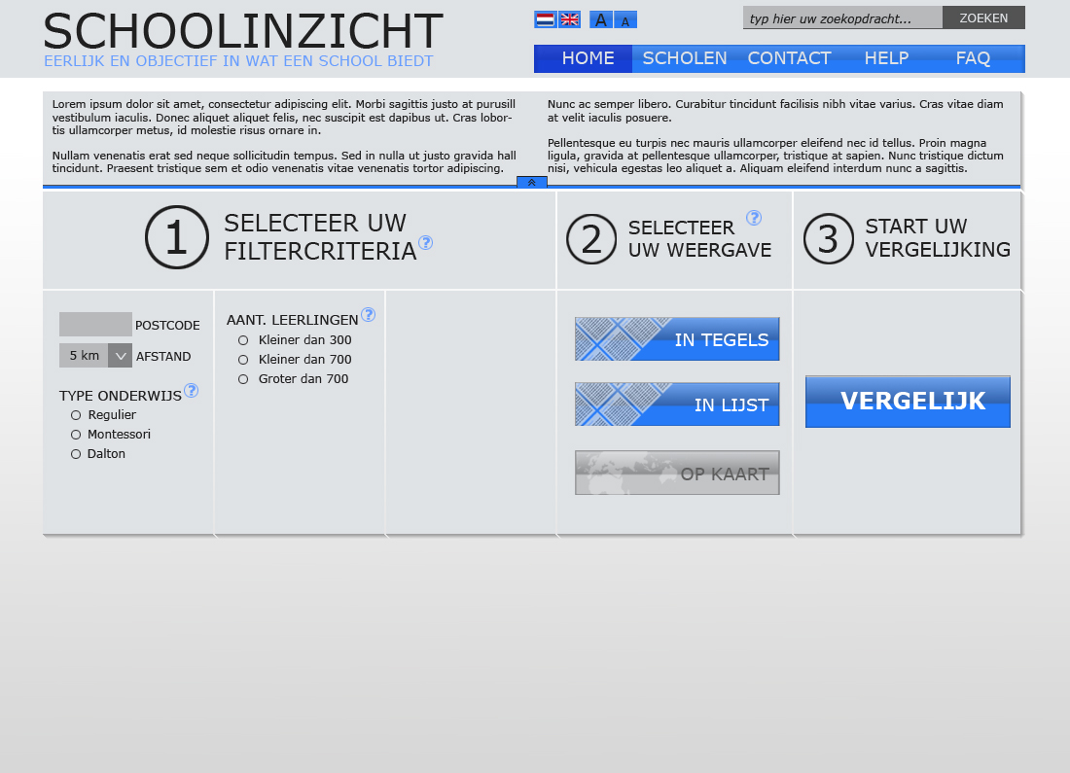

**PAGE 1a HOME**

This is the homepage; the first page a user views when visiting the application. A user can start a comparison by selecting criteria and selecting one of the three available view options.

The info area is expanded, containing basic information about the website.

The “MAP” (“OP KAART”) view button is grayed out. This is because the user has not filled in a postal code.

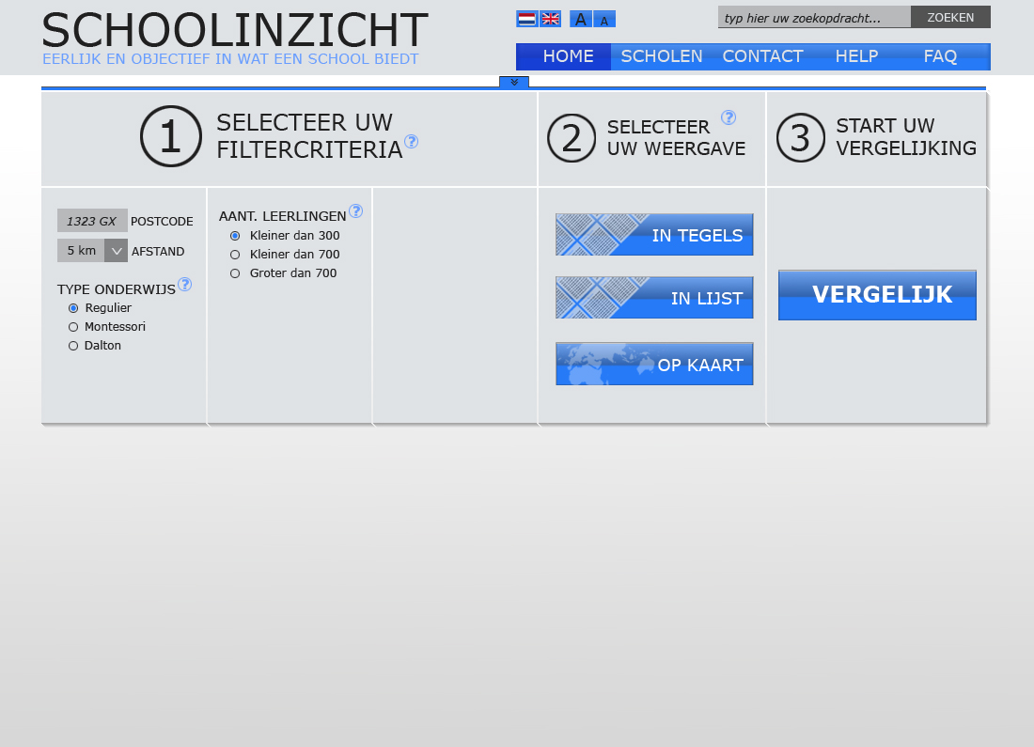

**PAGE 1b HOME**

This is the same page as the one above.

In this case the user has closed the info area.

The “MAP” button is no longer grayed out because a postal code has now been filled in by the user.

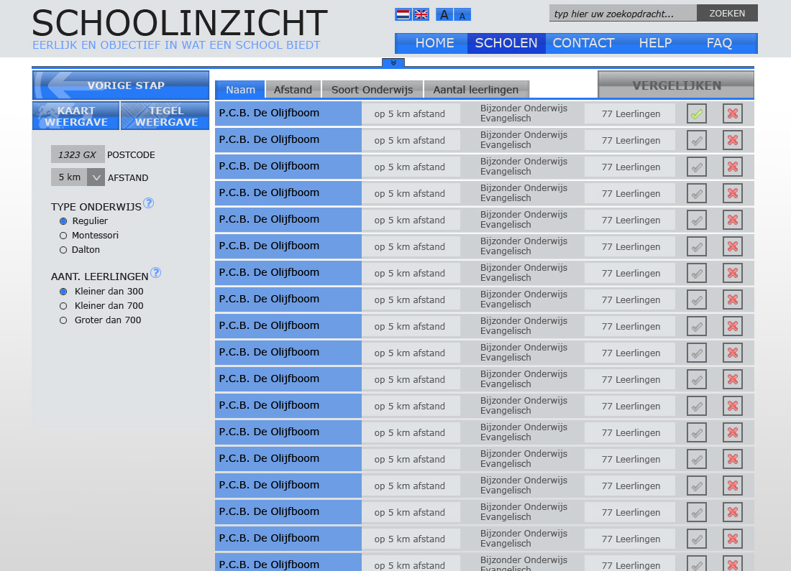

**PAGE 2a LIST**

This is the second page, the user gets here by selecting criteria, and if desired the “LIST” (“LIJST”) view.

If a user does not select one of the three view options this is the basic view.

Switching to other views is possible by using the buttons at the left. A user can also go one step backwards by using the “Back” (“VORIGE STAP”) button. Furthermore a user can edit the selected criteria as desired.

The tabs, available above the list, sort the results (items).

A user can also delete or select an item from the list by using the buttons at the far right of each item.

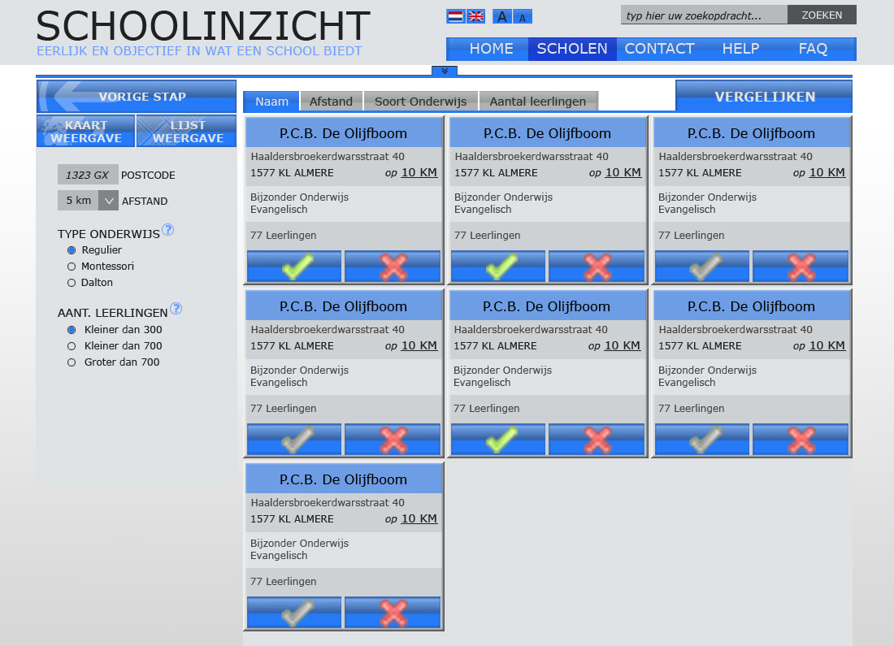

**PAGE 2b TILES**

The tile view page is functionally the same as the listpage.

This design was primarily created for easy use on tablets.

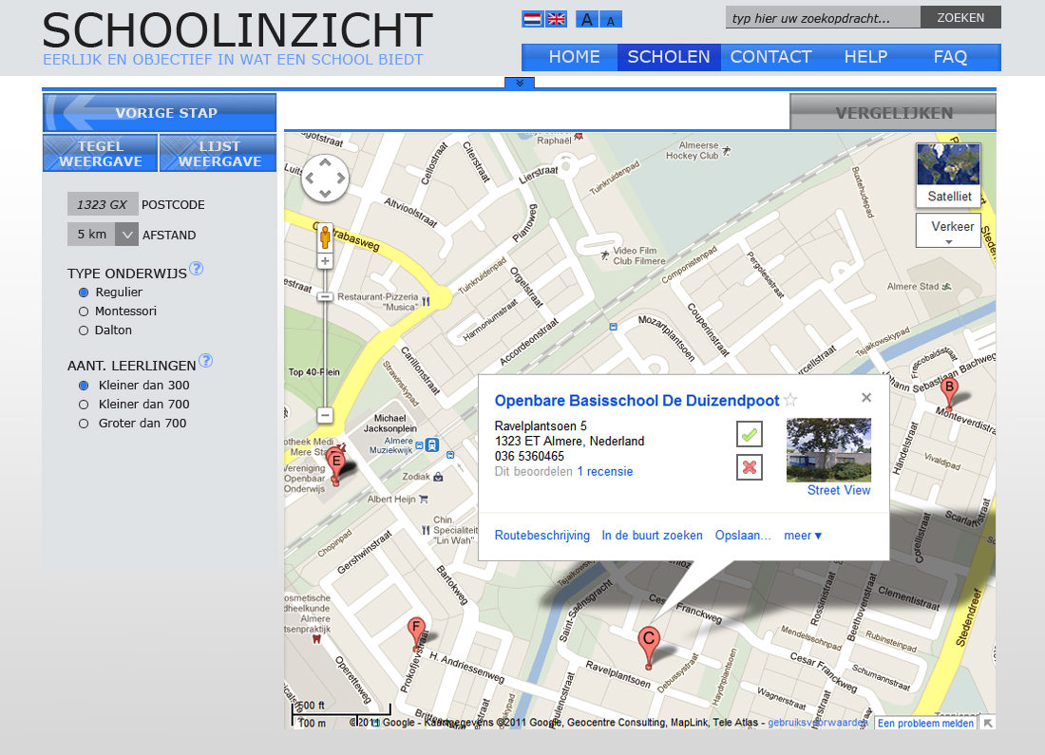

**PAGE 2c MAP**

A user can view schools by location on this view. This is also the reason for the missing sorting tabs.

When 2 or 3 schools are selected for comparison a user can compare the selected schools by clicking the “VERGELIJKEN” button, which will no longer be grayed out after the selection.

***This goes for all view pages.***

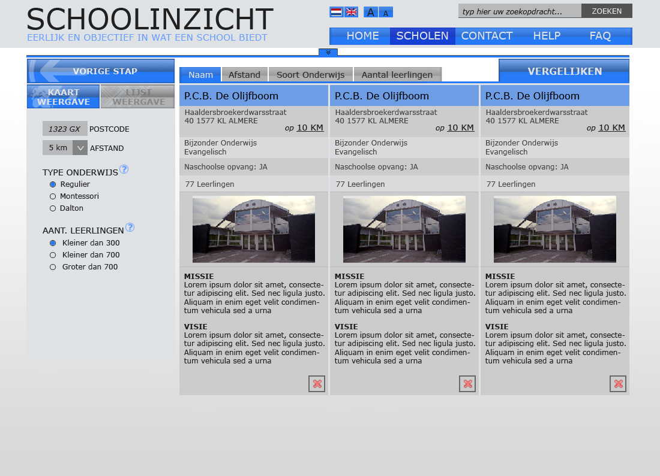

**PAGE 3 SELECTION**

A user ends up on this paage after clicking the “VERGELIJKEN” button on one of the view pages.

On this page the user has more detailed information available about the previously selected schools.

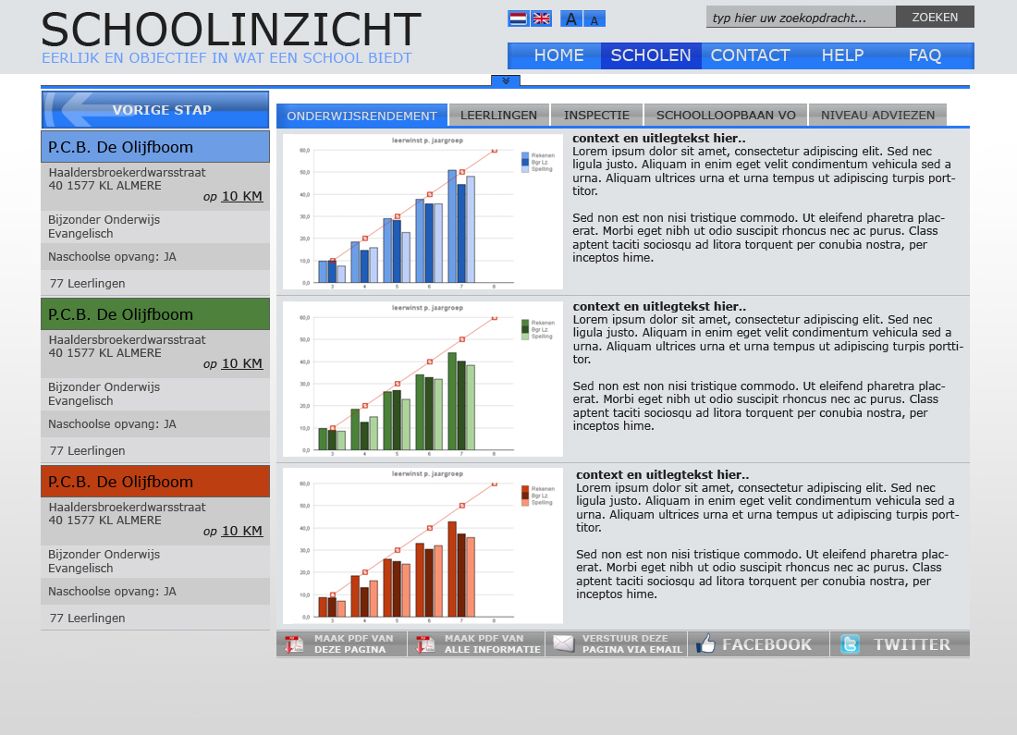

**PAGE 4a COMPARISON**

This page displays even more detailed information about the previously selected schools.

A user gets to this page by using the “VERGELIJKEN” button again, from the selectionpage.

The selected schools now replace the criteria on the left, making place for graphs and text on the right.

All of the available information is sorted in the tabs above the contentarea.

More options are available below the content area. A user can make a PDF of the currently selected tab or all tabs at once. A user can also send a link of this particular comparison via e-mail. Furthermore facebook and twitter options are also available. All of these options open a new window.

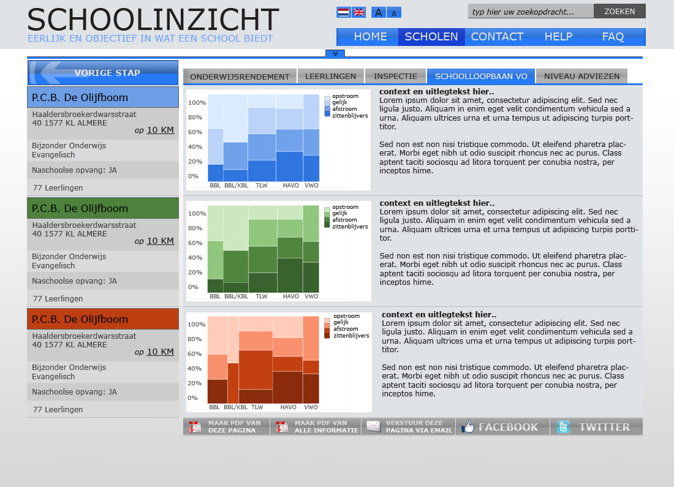

**PAGE 4b COMPARISON**

This page displays the information on a different tab.

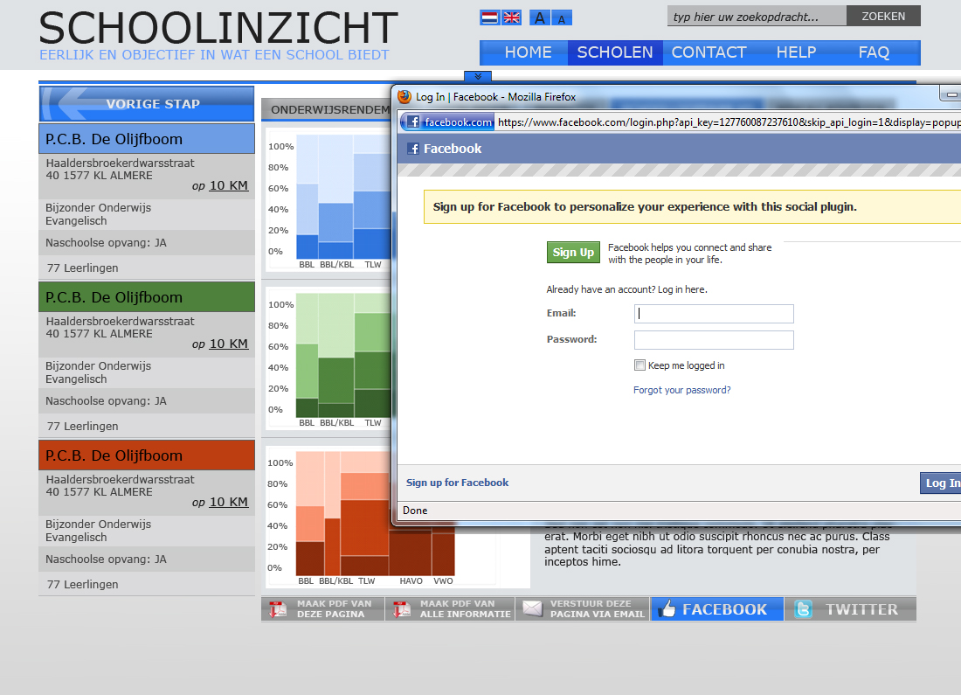

**PAGE 4c COMPARISON**

Other than the active social media button for facebook this is the same page as displayed above

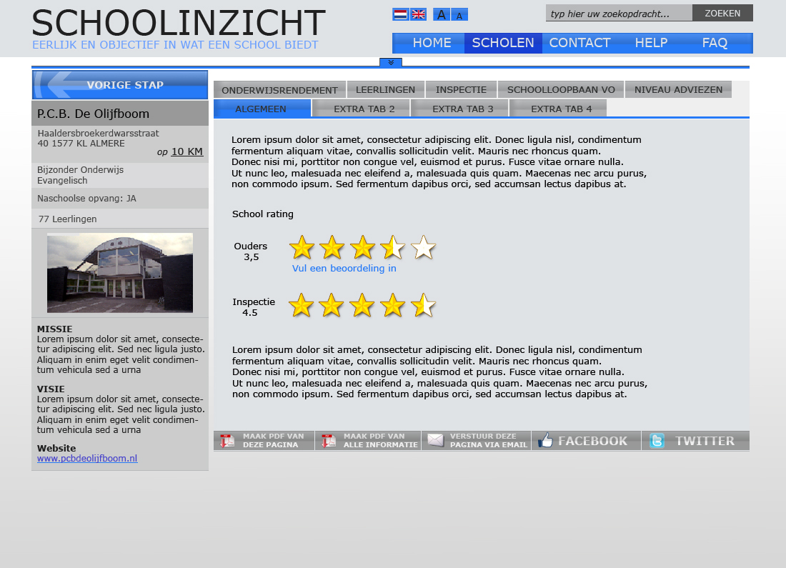

**PAGE 5a PROFILE**

On every page that displays schools, the user can click a schoolname to browse to the school’s profile, displayed here.

The user can view detailed information about one particular school here.

The general (“ALGEMEEN”) tab displays the rating system.

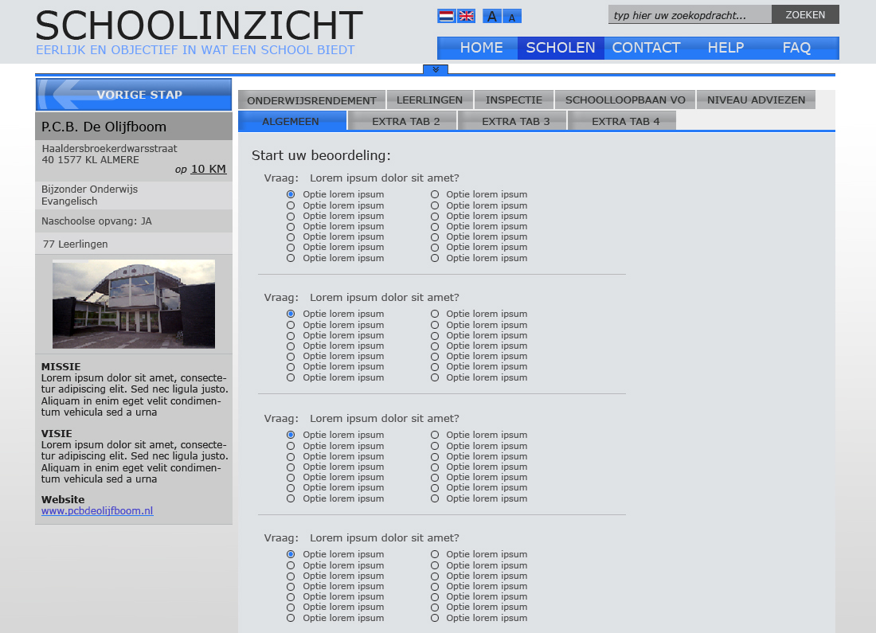

**PAGE 5b PROFILE**

The user can rate a school from this page. The user browsed to this page by clicking the “vul een beoordeling in” link, available on the “ALGEMEEN” tab.

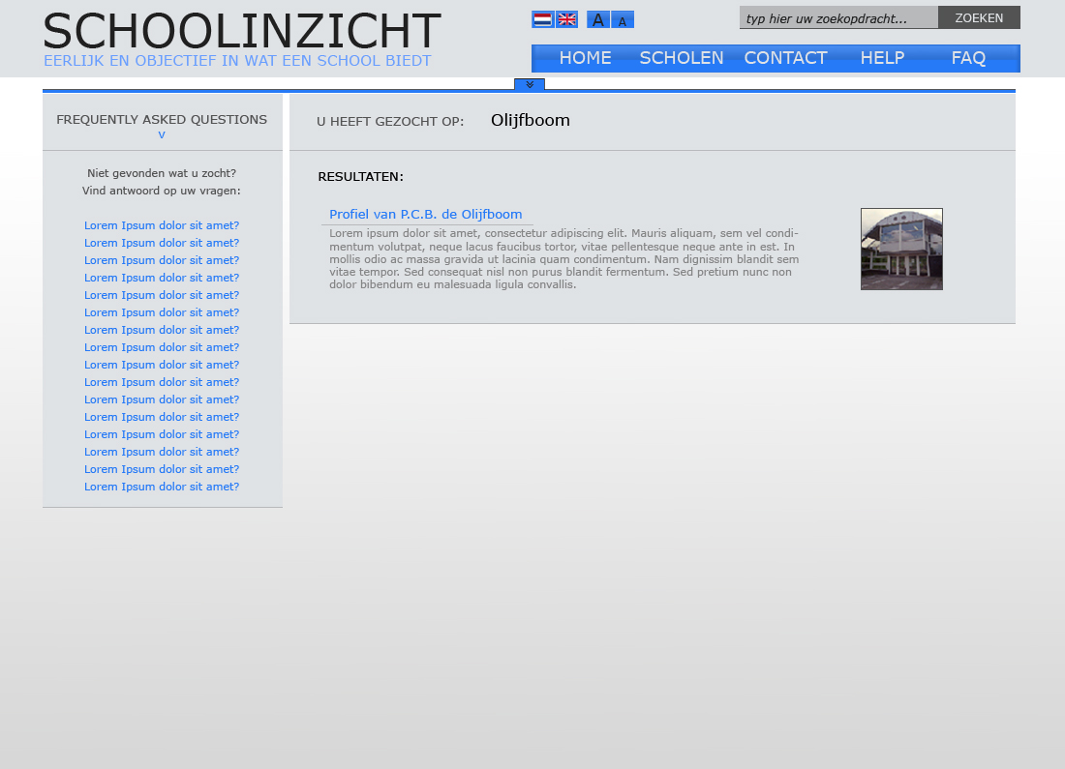

**PAGE 6 SEARCH**

A user browses to this page by using the search bar, available on every page at the top right.

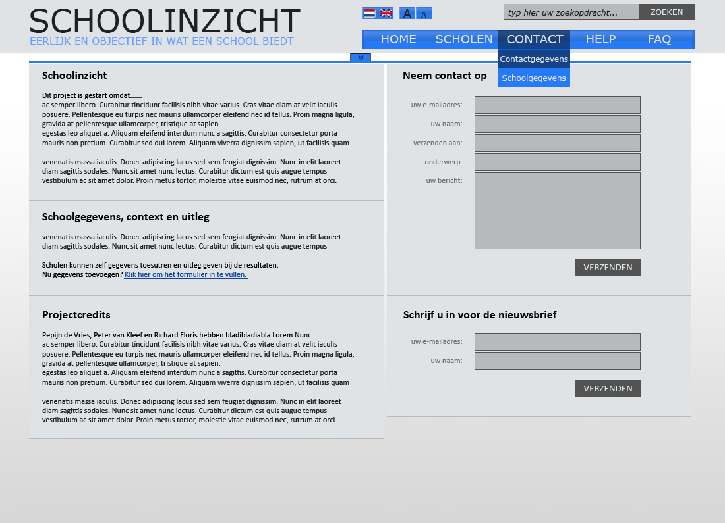

**PAGE 7 CONTACT**

The contact(gegevens) page displays basic information about the project. It also contains a contact form, which the user can use to contact admin.

Furthermore a user can

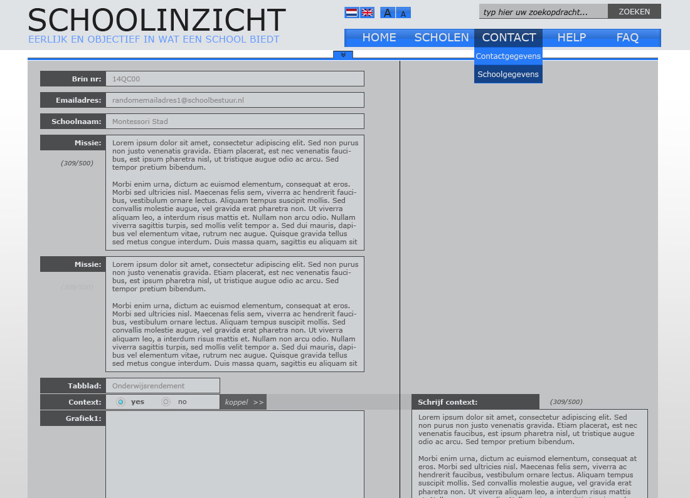

**PAGE 8 SCHOOLFORM**

After logging in with an e-mailaddress and the unique schoolcode a schooladmin can view this page.

An admin can view all information available about a school. The admin can edit certain items.

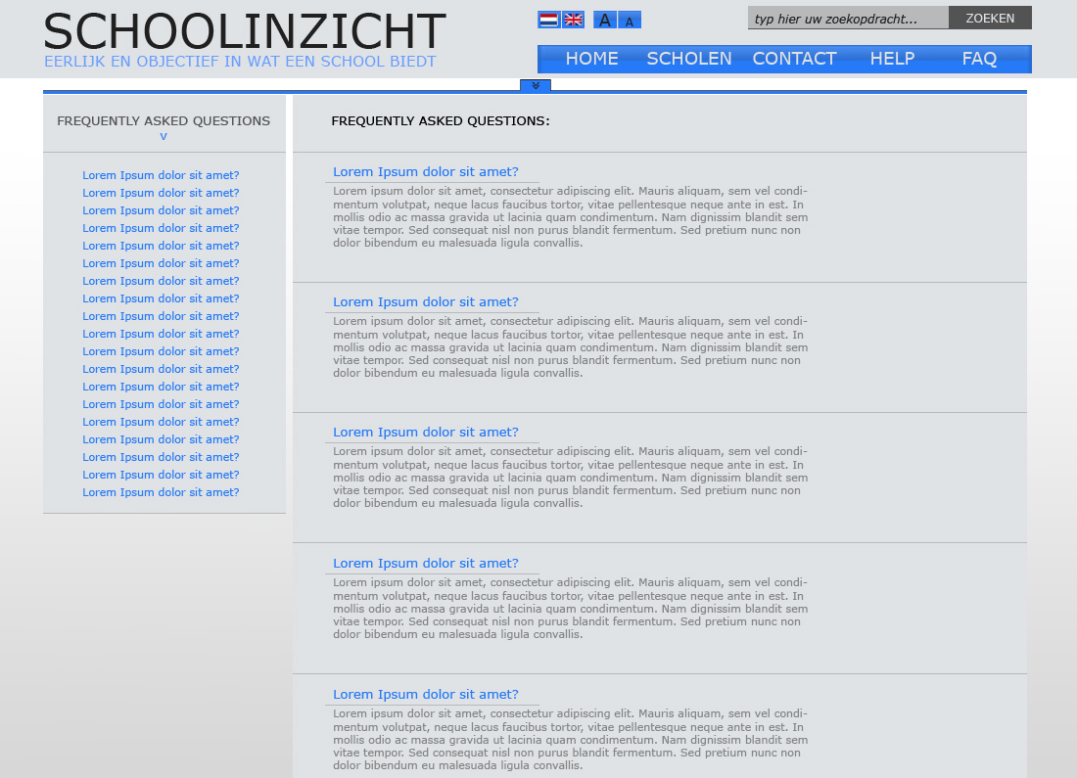

**PAGE 9 FAQ**

This is the page containing frequently asked questions.

A list of all available questions is displayed at the left. When a user clicks one of the displayed list items he will be forwarded to the selected question.

## 9.2 Back End

Screenshots of the back end prototype are presented on the following pages.

The name of each page and a short explanatory text are included to the right of each screenshot.

Screenshots start at the next page

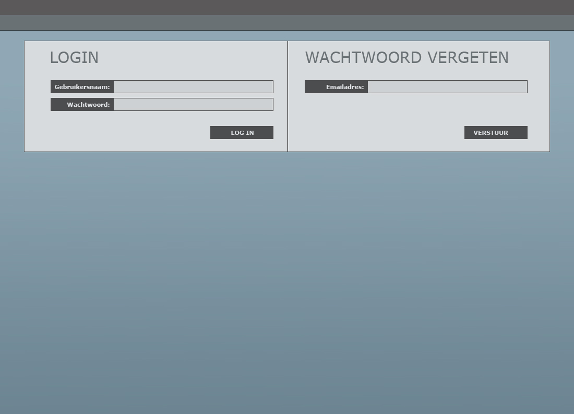

**PAGE 0 LOGIN**

This is the login page (back-end). This is where the admin can log in and get a new password when he forgets his password.

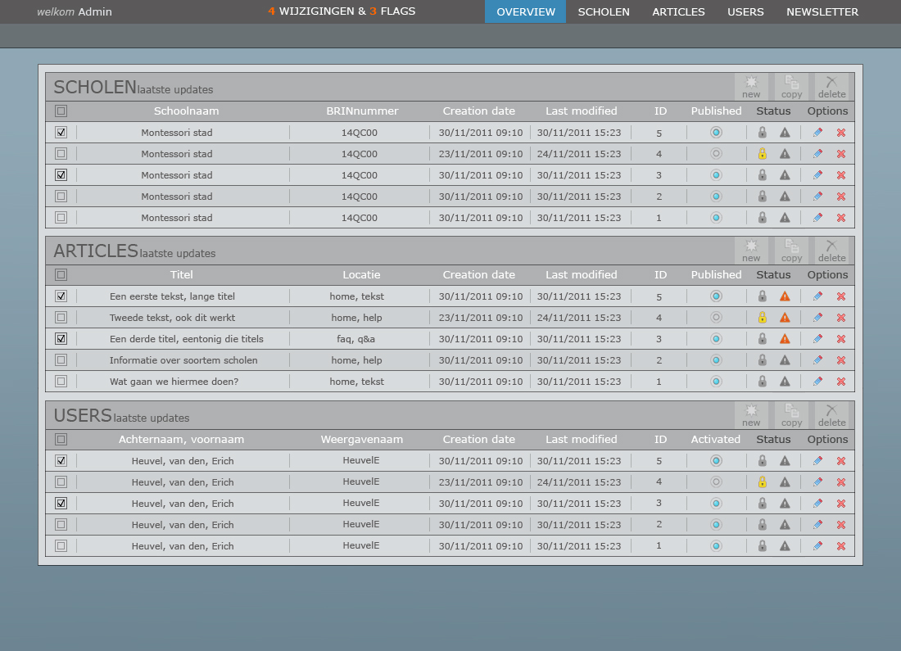

**PAGE 1 OVERVIEW**

This is the first page on the back-end where you get an overview of all the articles that can be managed.

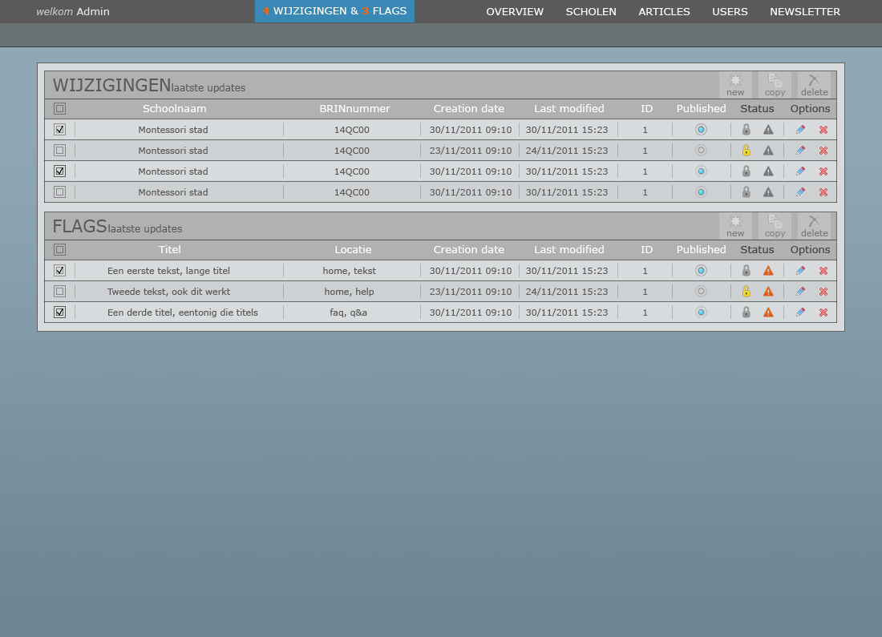

**PAGE 0 WIJZIGINGEN & UPDATES**

On this page you can see the recently changed and flagged articles.

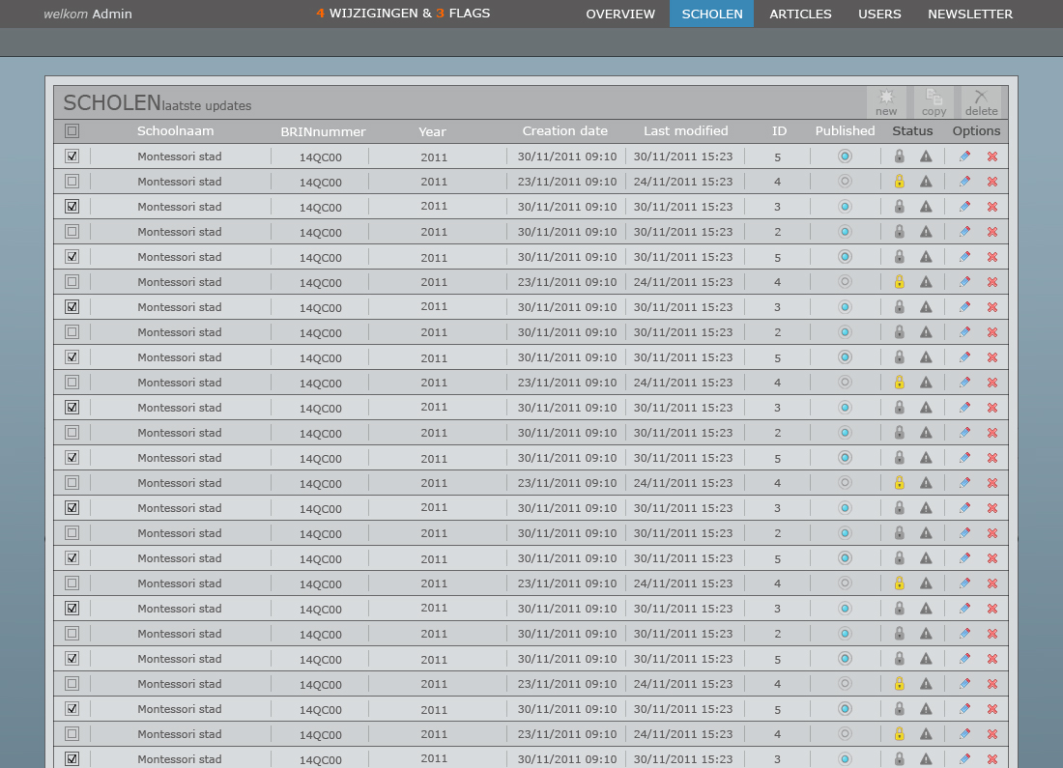

**PAGE 2 SCHOLEN**

In this article manage page the visitor can see all the schools.

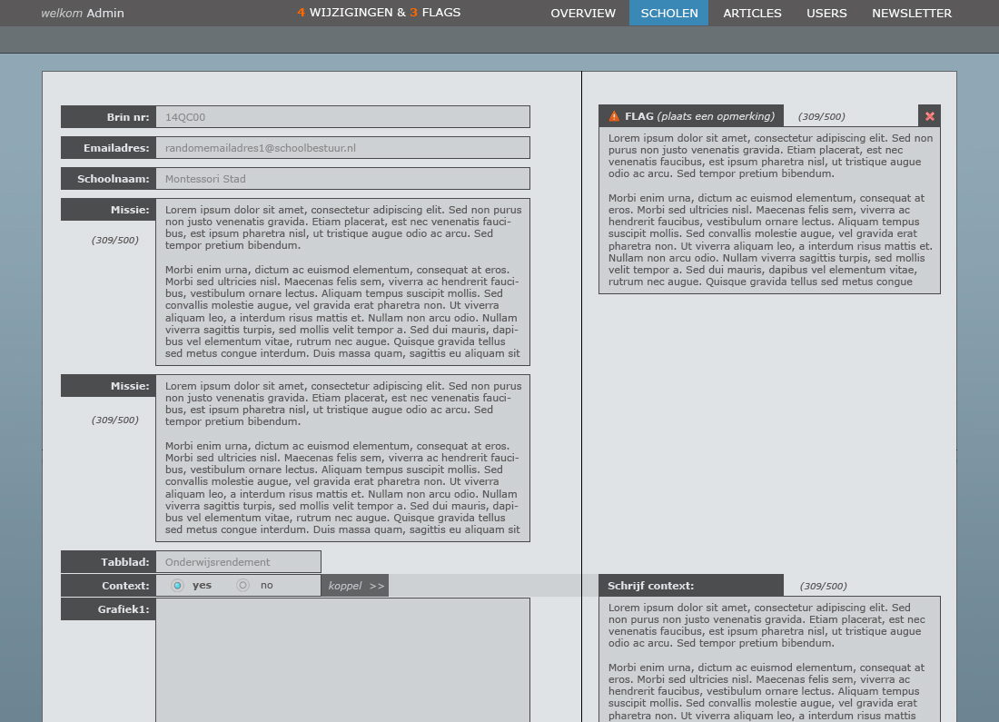

**PAGE 2a EDIT SCHOOLS**

One of the most important pages is the edit/review school page. The admin accepts or denies school information updates and send an email.

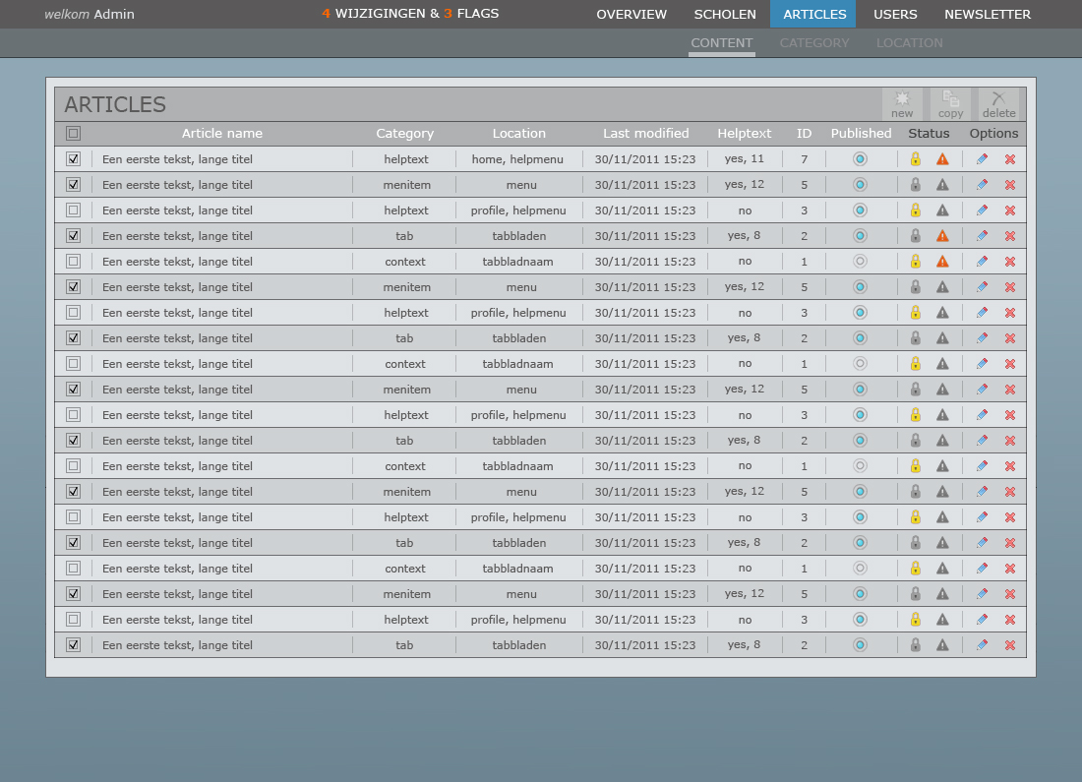

**PAGE 3 CONTENT - ARTICLES**

In this page all the content articles are managed. All menu items, info texts etc. are managed in articles. This way you are able to change all texts without “programming”.

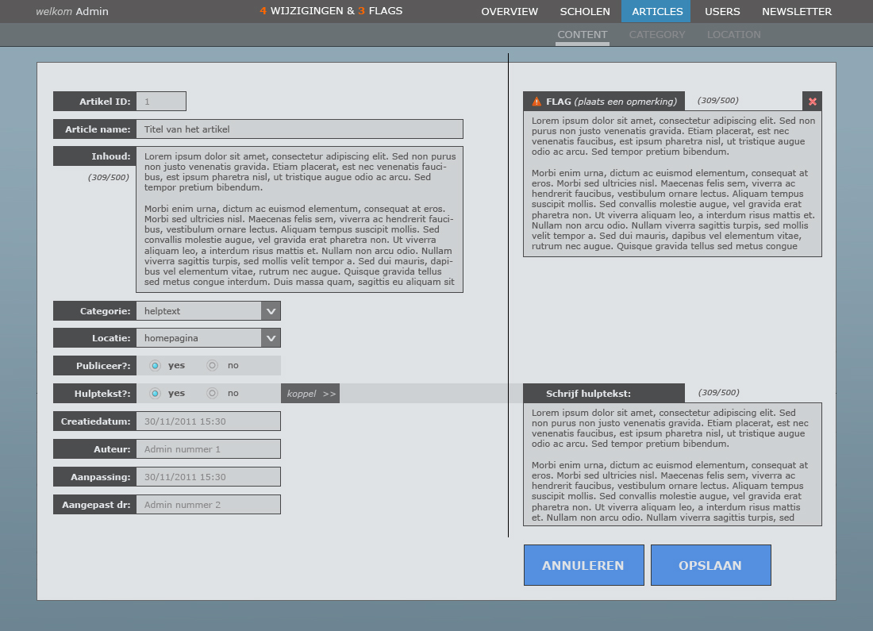

**PAGE 3a EDIT CONTENT - ARTICLES**

The edit page contains the flag function like all the articles. Here, admins can send comment to each other when they have spotted an error but don’t have the rights.

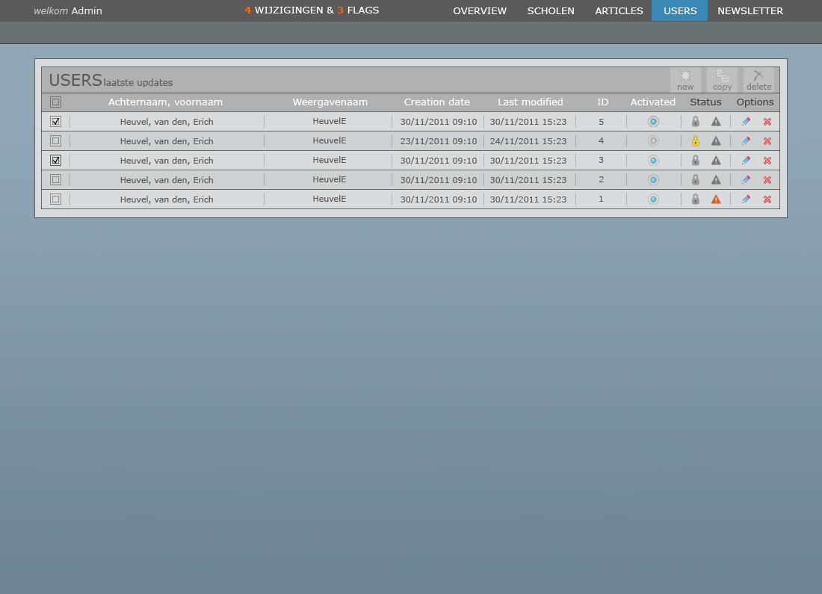

**PAGE 4 USERS**

Admins can get an overview of all users active and inactive within the system from this screen. A user can be edited by either clicking the ‘Achternaam, voornaam’ or the ‘Weergavenaam’ fields of a specific record. This can also be achieved by clicking the ‘pencil’ icon at the right.

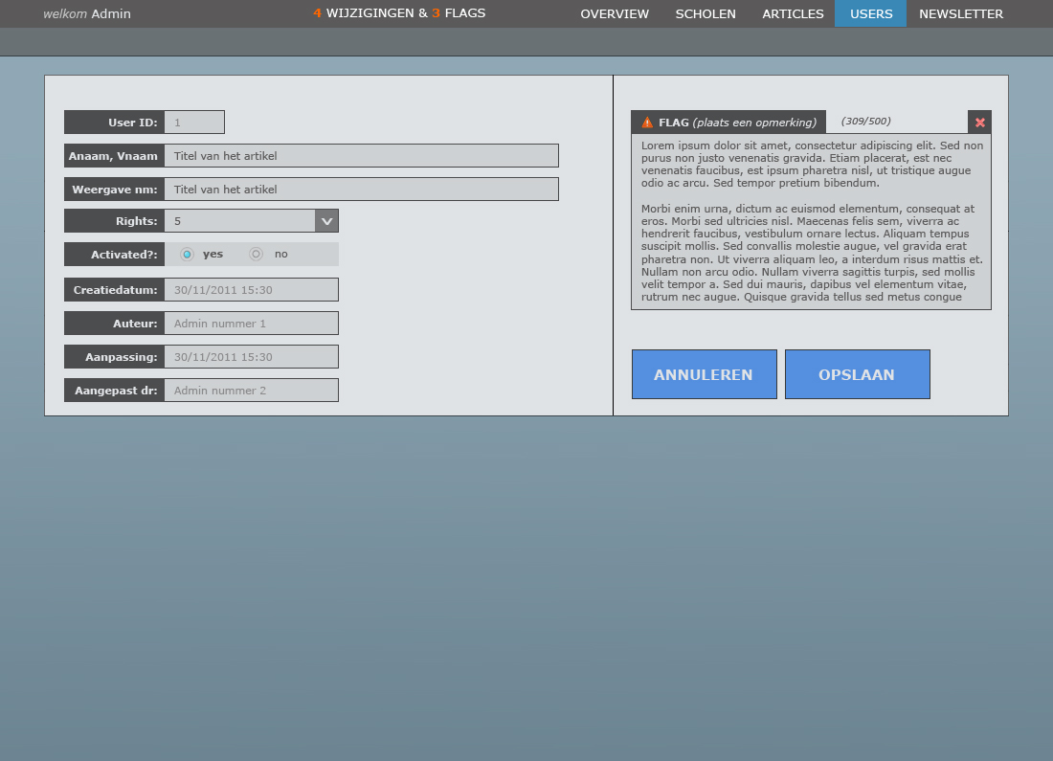

**PAGE 4a EDIT USERS**

A highlevel admin can edit (lowlevel) accounts, granting them more or less ‘rights’.

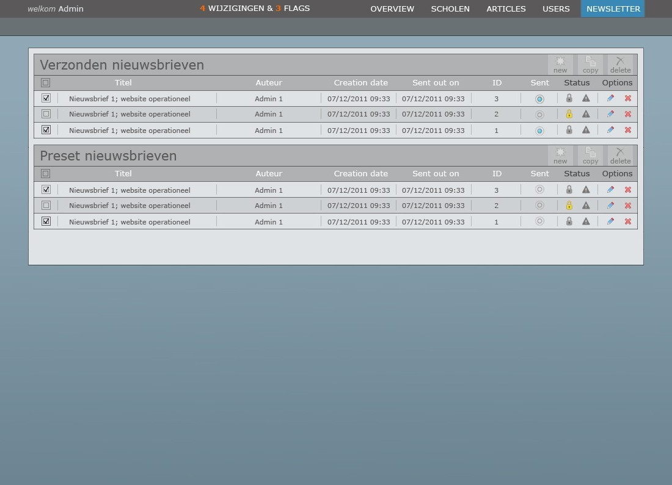

**PAGE 5 NEWSLETTER**

On this page an admin can read either sent or later to be sent (concept) newsletters. Admins can also create new newsletters (empty or from preset).

# 10 Graphic design details

This chapter contains the detail of all of the visual aspects used in the prototype. This will allow programmers to easily retrieve visual details if they would need to modify the website. The backend does not have a hyperlink section seeing as it’s a normal content management system and no special hyperlink requirements have been made.

## 10.1 Front end typography

|  |  |  |  |  |  |
| --- | --- | --- | --- | --- | --- |
| ID | Location | Details | | | |
| 1.1 | **Menu bar**  **/all pages** | ***Font used:*** | Verdana | ***Font color:*** | #dfe5e5 |
| ***Size used:*** | 18 |  |  |
| ***Attributes used:*** | *None (regular)* |  |  |
| *Description/Justification:* Color chosen to optimize contrast. The light gray tint makes the text less flashy but leaves the buttons easily recognizable. The ‘verdana’ font was chosen because it is a standard font, accessible to every future user. Text is written in capital to add extra conspicuousness. | | | | |
| 1.2 | **‘vergelijk’button**  **/all pages, exception: home** | ***Font used:*** | Verdana | ***Font color:*** | #dfe5e5 |
| ***Size used:*** | 16 |  |  |
| ***Attributes used:*** | *Bold* |  |  |
| *Description/Justification:*  See 1.1, font-size reduced due to usage of the bold attribute. This attribute is used to increase the conspicuousness of the button. | | | | |
| 1.3 | **‘vorige stap’ button**  **/all pages, exception: home** | ***Font used:*** | Verdana | ***Font color:*** | #dfe5e5 |
| ***Size used:*** | 14 |  |  |
| ***Attributes used:*** | *Bold* |  |  |
| *Description/Justification:*  See 1.1 & 1.2, font-size further reduced to reduce conspicuousness. | | | | |
| 1.4 | **‘weergave’ buttons**  **/all pages, exception: home** | ***Font used:*** | Verdana | ***Font color:*** | #dfe5e5 |
| ***Size used:*** | 14 |  |  |
| ***Attributes used:*** | *Bold* |  |  |
| *Description/Justification:*  See 1.1 & 1.2, font-size further reduced to reduce conspicuousness. | | | | |
| 1.5 | **Headings**  **/all pages** | ***Font used:*** | Verdana | ***Font color:*** | #202020 |
| ***Size used:*** | 14 |  |  |
| ***Attributes used:*** | *None (regular)* |  |  |
| *Description/Justification:*  Color chosen to optimize contrast. The dark gray tint makes text easy to read but adds less contrast to the text than pure black would. The ‘verdana’ font was chosen to maintain the overall look and feel of the application. | | | | |
| 1.6 | **Text**  **/all pages** | ***Font used:*** | Verdana | ***Font color:*** | #202020 |
| ***Size used:*** | 12 |  |  |
| ***Attributes used:*** | *None (regular)* |  |  |
| *Description/Justification:*  See 1.5, font size reduced to generate a distinct difference from the text as opposed to headings. | | | | |
| 1.7 | **‘ZOEKEN’**  **/all pages** | ***Font used:*** | Verdana | ***Font color:*** | #dfe2e5 |
| ***Size used:*** | 12 |  |  |
| ***Attributes used:*** | *None (regular)* |  |  |
| *Description/Justification:*  White text adds nice contrast to the dark gray background, no attribute used to lower conspicuousness. | | | | |
| 1.8 | **Voorbeeld “ZOEKEN”**  **/all pages** | ***Font used:*** | Verdana | ***Font color:*** | #202020 |
| ***Size used:*** | 12 |  |  |
| ***Attributes used:*** | *None (regular)* |  |  |
| *Description/Justification:*  - | | | | |

## 10.2 Front end color

|  |  |  |  |  |  |
| --- | --- | --- | --- | --- | --- |
| ID | Location | Details | | | |
| 1.1 | **Header background**  **/all pages** | ***Color 1 used:*** | #dfe2e5 |  |  |
| ***Color 2 used:*** | *None* |  |  |
| ***Attributes used:*** | *None* |  |  |
| *Description/Justification:* Light gray background that stands out. A light background allows the text to be dark, which contributes to usability (dark text on light background reads easier than light on dark). | | | | |
| 1.2 | **Page background**  **/all pages** | ***Color 1 used:*** | #ffffff |  |  |
| ***Color 2 used:*** | #d4d4d4 |  |  |
| ***Attributes used:*** | *Gradient (1-2)* |  |  |
| *Description/Justification:*  See 1.1, font-size reduced due to usage of the bold attribute. This attribute is used to increase the conspicuousness of the button. | | | | |
| 1.3 | **Search bar background**  **/all pages** | ***Color 1 used:*** | #b7b9bb |  |  |
| ***Color 2 used:*** | *None* |  |  |
| ***Attributes used:*** | *None* |  |  |
| *Description/Justification:*  By making the search bar darker than the background it stands out. | | | | |
| 1.4 | **Search bar button**  **/all pages** | ***Color 1 used:*** | #525353 |  |  |
| ***Color 2 used:*** | *None* |  |  |
| ***Attributes used:*** | *None* |  |  |
| *Description/Justification:*  Search button stands out because it’s even darker. | | | | |
| 1.5 | **Menu bar + buttons normal**  **/all pages** | ***Color 1 used:*** | #4387eb |  |  |
| ***Color 2 used:*** | #267af7 |  |  |
| ***Attributes used:*** | *Gloss (1 over 2)* |  |  |
| *Description/Justification:*  Blue used, all hyperlinks are blue with white text. | | | | |
| 1.6 | **Menu bar highlight**  **/all pages** | ***Color 1 used:*** | #0f4698 |  |  |
| ***Color 2 used:*** | *None* |  |  |
| ***Attributes used:*** | *None* |  |  |
| *Description/Justification:*  Darker blue, to show the user which page is active, or which menu item is being hovered. | | | | |
| 1.7 | **“Content” background**  **/all pages** | ***Color 1 used:*** | #dfe2e5 |  |  |
| ***Color 2 used:*** | *None* |  |  |
| ***Attributes used:*** | *None* |  |  |
| *Description/Justification:*  See 1.1 | | | | |
| 1.8 | **“Helptext” closebutton**  **/all pages** | ***Color 1 used:*** | #267af7 |  |  |
| ***Color 2 used:*** | *None* |  |  |
| ***Attributes used:*** | *None* |  |  |
| *Description/Justification:*  Blue used to maintain consistency with other ‘clickable’ parts. | | | | |
| 1.9 | **“postcode/afstand” bar**  **/all pages, exeption:**  **Profile pages** | ***Color 1 used:*** | #b7b9bb |  |  |
| ***Color 2 used:*** | *None* |  |  |
| ***Attributes used:*** | *None* |  |  |
| *Description/Justification:* | | | | |
| 1.10 | **“afstand” dropdown**  **/all pages, exeption:**  **Profile pages** | ***Color 1 used:*** | #828485 |  |  |
| ***Color 2 used:*** | *None* |  |  |
| ***Attributes used:*** | *None* |  |  |
| *Description/Justification:* | | | | |
| 1.11 | **Buttons grayed out**  **/all pages** | ***Color 1 used:*** | #9b9c9e |  |  |
| ***Color 2 used:*** | #c2c4c6 |  |  |
| ***Attributes used:*** | *Gloss (1 over 2)* |  |  |
| *Description/Justification:* | | | | |
| 1.12 | **List title**  **/comparison pages** | ***Color 1 used:*** | #6d9de4 |  |  |
| ***Color 2 used:*** | *None* |  |  |
| ***Attributes used:*** | *None* |  |  |
| *Description/Justification:* | | | | |
| 1.13 | **List dark**  **/comparison pages** | ***Color 1 used:*** | #ced1d3 |  |  |
| ***Color 2 used:*** | *None* |  |  |
| ***Attributes used:*** | *None* |  |  |
| *Description/Justification:* | | | | |

## 10.3 Front end layout

|  |  |  |  |  |  |
| --- | --- | --- | --- | --- | --- |
| ID | Location | Details | | | |
| 1.1 | **Header**  **/all pages** | ***Height:*** | *80 px* |  |  |
| ***Width:*** | *100 %* |  |  |
|  |  |  |  |
| 1.2 | **“ZOEKEN” bar**  **/all pages** | ***Height:*** | *23 px* |  |  |
| ***Width:*** | *205 px* |  |  |
| ***Attribute*** | *Border bottom 1px* |  |  |
| 1.3 | **“ZOEKEN” button**  **/all pages** | ***Height:*** | 23 px |  |  |
| ***Width:*** | *85 px* |  |  |
|  |  |  |  |
| 1.4 | **Menu bar item**  **/all pages** | ***Height:*** | *16 px* |  |  |
| ***Width:*** | *Relative to content; padding-left & right: 16px* | | |
|  |  |  |  |
| 1.5 | **LOGO**  **/all pages** | ***Height:*** |  |  |  |
| ***Width:*** |  |  |  |
|  |  |  |  |
| 1.6 | **CONTENT total**  **/all pages** | ***Height:*** | *Relative to content* | | |
| ***Width:*** | *MAX: 1010 px* |  |  |
|  |  |  |  |
| 1.7 | **Content left top**  **/homepage** | ***Height:*** | *100 px* |  |  |
| ***Width:*** | *527 px* |  |  |
|  |  |  |  |
| 1.8 | **Content left column (3x)**  **/homepage** | ***Height:*** | *250 px* |  |  |
| ***Width:*** | *175 px* |  |  |
|  |  |  |  |
| 1.9 | **Content mid top**  **/homepage** | ***Height:*** | *100 px* |  |  |
| ***Width:*** | *241 px* |  |  |
|  |  |  |  |
| 1.10 | **Content mid column**  **/homepage** | ***Height:*** | *250 px* |  |  |
| ***Width:*** | *241 px* |  |  |
|  |  |  |  |
| 1.11 | **Content right top**  **/homepage** | ***Height:*** | *100 px* |  |  |
| ***Width:*** | *233 px* |  |  |
|  |  |  |  |
| 1.12 | **Content right column**  **/homepage** | ***Height:*** | *250 px* |  |  |
| ***Width:*** | *233 px* |  |  |
|  |  |  |  |
| 1.13 | **“weergave” buttons**  **/homepage** | ***Height:*** | *45 px* |  |  |
| ***Width:*** | *211 px* |  |  |
|  |  |  |  |
| 1.14 | **“VERGELIJK” button**  **/homepage** | ***Height:*** | *54 px* |  |  |
| ***Width:*** | *211 px* |  |  |
|  |  |  |  |
| 1.15 | **“POSTCODE” area /all pages** | ***Height:*** | *25 px* |  |  |
| ***Width:*** | *75 px* |  |  |
|  |  |  |  |
| 1.16 | **“AFSTAND” dropdown /all pages** | ***Height:*** | *25 px* |  |  |
| ***Width:*** | *25 px* |  |  |
|  |  |  |  |
| 1.17 | **“AFSTAND” area**  **/all pages** | ***Height:*** | *25 px* |  |  |
| ***Width:*** | *50 px* |  |  |
|  |  |  |  |
| 1.18 | **“VORIGE STAP” button**  **/all pages, exception:**  **homepage** | ***Height:*** | *41 px* |  |  |
| ***Width:*** | *246 px* |  |  |
|  |  |  |  |
| 1.19 | **“WEERGAVE” buttons**  **/all pages, exception:**  **homepage** | ***Height:*** | *41 px* |  |  |
| ***Width:*** | *123 px* |  |  |
|  |  |  |  |
| 1.20 | **“TABBLADEN”**  **/all pages, exception:**  **homepage** | ***Height:*** | *24 px* |  |  |
| ***Width*** | *Relative to content* |  | |
| ***Attribute:*** | *Margin-right: 1px Padding-left + right: 14px* | | |
| 1.21 | **“VERGELIJKKNOP”**  **/all pages, exception:**  **homepage** | ***Height:*** | *38px* |  |  |
| ***Width:*** | *218px* |  |  |
|  |  |  |  |
| 1.22 | **“LIST ITEM” title**  **/listpage** | ***Height:*** | *34 px* |  |  |
| ***Width:*** | *204 px* |  |  |
|  |  |  |  |
| 1.23 | **“LIST ITEM” box 1**  **/listpage** | ***Height:*** | *34 px* |  |  |
| ***Width:*** | *137 px* |  |  |
|  |  |  |  |
| 1.24 | **“LIST ITEM” box 2**  **/listpage** | ***Height:*** | *34 px* |  |  |
| ***Width:*** | *173 px* |  |  |
|  |  |  |  |
| 1.25 | **“LIST ITEM” box 3**  **/listpage** | ***Height:*** | *34 px* |  |  |
| ***Width:*** | *126 px* |  |  |
|  |  |  |  |
| 1.26 | **“LIST ITEM” box 4**  **/listpage** | ***Height:*** | *34 px* |  |  |
| ***Width:*** | *110 px* |  |  |
|  |  |  |  |
| 1.27 | **“TILE ITEM” title**  **/tilepage** | ***Height:*** | *37 px* |  |  |
| ***Width:*** | *242 px* |  |  |
|  |  |  |  |
| 1.28 | **“TILE ITEM” box 1**  **/tilepage** | ***Height:*** | *48 px* |  |  |
| ***Width:*** | *242 px* |  |  |
|  |  |  |  |
| 1.29 | **“TILE ITEM” box 2**  **/tilepage** | ***Height:*** | *44 px* |  |  |
| ***Width:*** | *242 px* |  |  |
|  |  |  |  |
| 1.30 | **“TILE ITEM” box 3**  **/tilepage** | ***Height:*** | *35 px* |  |  |
| ***Width:*** | *24 2px* |  |  |
|  |  |  |  |
| 1.31 | **“TILE ITEM” buttons**  **/tilepage** | ***Height:*** | *39 px* |  |  |
| ***Width:*** | *118 px* |  |  |
|  |  |  |  |
| 1.32 | **“COMPARISON” title**  **/comparisonpage** | ***Height:*** | *35 px* |  |  |
| ***Width:*** | *248 px* |  |  |
|  |  |  |  |
| 1.33 | **“COMPARISON” box 1**  **/comparisonpage** | ***Height:*** | *52 px* |  |  |
| ***Width:*** | *248 px* |  |  |
|  |  |  |  |
| 1.34 | **“COMPARISON” box 2**  **/comparisonpage** | ***Height:*** | *35 px* |  |  |
| ***Width*** | *248 px* |  |  |
|  |  |  |  |
| 1.35 | **“COMPARISON” box 3**  **/comparisonpage** | ***Height:*** | *29 px* |  |  |
| ***Width:*** | *248 px* |  |  |
|  |  |  |  |
| 1.36 | **“COMPARISON” box 4**  **/comparisonpage** | ***Height:*** | *27 px* |  |  |
| ***Width:*** | *248 px* |  |  |
|  |  |  |  |
| 1.37 | **“COMPARISON” box 5**  **/comparisonpage** | ***Height:*** | *126 px* |  |  |
| ***Width:*** | *248 px* |  |  |
|  |  |  |  |
| 1.38 | **“COMPARISON” picture**  **/comparisonpage** | ***Height:*** | *112 px* |  |  |
| ***Width:*** | *204 px* |  |  |
|  |  |  |  |
| 1.32 | **“COMPARISON” box 6**  **/comparisonpage** | ***Height:*** | *215 px* |  |  |
| ***Width:*** | *248 px* |  |  |
|  |  |  |  |

## 10.4 Front end hyperlinks

All hyperlinks and 90% of all buttons have been assigned the color blue.

## 10.5 Back end typography

|  |  |  |  |  |  |
| --- | --- | --- | --- | --- | --- |
| ID | Location | Details | | | |
| 1.2 | **Menu bar**  **/all pages** | ***Font used:*** | Verdana | ***Font color:*** | #ffffff |
| ***Size used:*** | 13 |  |  |
| ***Attributes used:*** | *None (regular)* |  |  |
| *Description/Justification:* | | | | |
| 1.3 | **Menu bar (notifications)**  **/all pages** | ***Font used:*** | Verdana | ***Font color:*** | #ff6600 |
| ***Size used:*** | 13 |  |  |
| ***Attributes used:*** | *None (regular)* |  |  |
| *Description/Justification:* | | | | |
| 1.4 | **Menu bar (“welkom”)**  **/all pages** | ***Font used:*** | Verdana | ***Font color:*** | #c4c5c5 |
| ***Size used:*** | 13 |  |  |
| ***Attributes used:*** | *None (regular)* |  |  |
| *Description/Justification:* | | | | |
| 1.5 | **Table (“headers”)**  **/all pages** | ***Font used:*** | Verdana | ***Font color:*** | #5b5a5a |
| ***Size used:*** | 21 |  |  |
| ***Attributes used:*** | *None (regular)* |  |  |
| *Description/Justification:* | | | | |
| 1.6 | **Table (“headers 2”)**  **/all pages** | ***Font used:*** | Verdana | ***Font color:*** | #5b5a5a |
| ***Size used:*** | 12 |  |  |
| ***Attributes used:*** | *None (regular)* |  |  |
|  | | | | |
| 1.7 | **Table (“columnames”)**  **/all pages** | ***Font used:*** | Verdana | ***Font color:*** | #ffffff |
| ***Size used:*** | 13 |  |  |
| ***Attributes used:*** | *None (regular)* |  |  |
| *Description/Justification:* | | | | |
| 1.8 | **Table (“columnames (status + options)”)**  **/all pages** | ***Font used:*** | Verdana | ***Font color:*** | #424242 |
| ***Size used:*** | 13 |  |  |
| ***Attributes used:*** | *None (regular)* |  |  |
| *Description/Justification:* | | | | |
| 1.9 | **Table (“items”)**  **/all pages** | ***Font used:*** | Verdana | ***Font color:*** | #5b5a5a |
| ***Size used:*** | 11 |  |  |
| ***Attributes used:*** | *None (regular)* |  |  |
| *Description/Justification:* | | | | |
| 1.10 | **Label (“items”)**  **/edit pages** | ***Font used:*** | Verdana | ***Font color:*** | #dfe2e5 |
| ***Size used:*** | 11 |  |  |
| ***Attributes used:*** | Bold |  |  |
| *Description/Justification:* | | | | |
| 1.11 | **Field (“items (available)”)**  **/edit pages** | ***Font used:*** | Verdana | ***Font color:*** | #5b5a5a |
| ***Size used:*** | 11 |  |  |
| ***Attributes used:*** | *None (regular)* |  |  |
| *Description/Justification:* | | | | |
| 1.12 | **Field (“items (nonavailable)”)**  **/edit pages** | ***Font used:*** | Verdana | ***Font color:*** | #8a8b8c |
| ***Size used:*** | 11 |  |  |
| ***Attributes used:*** | *None (regular)* |  |  |
| *Description/Justification:* | | | | |
| 1.13 | **“toon grafiek” button**  **/edit pages** | ***Font used:*** | Verdana | ***Font color:*** | #272727 |
| ***Size used:*** | 11 |  |  |
| ***Attributes used:*** | Bold |  |  |
| *Description/Justification:* | | | | |
| 1.14 | **“OPSLAAN” & “ANNULEREN” buttons**  **/edit pages** | ***Font used:*** | Verdana | ***Font color:*** | #dfe2e5 |
| ***Size used:*** | 15 |  |  |
| ***Attributes used:*** | Bold |  |  |
| *Description/Justification:* | | | | |

## 10.6 Back end color

|  |  |  |  |  |  |
| --- | --- | --- | --- | --- | --- |
| ID | Location | Details | | | |
| 1.1 | **Header 1 background**  **/all pages** | ***Color 1 used:*** | #5b5a5a |  |  |
| ***Color 2 used:*** | *None* |  |  |
| ***Attributes used:*** | *None* |  |  |
| *Description/Justification:* | | | | |
| 1.2 | **Header 2 Background**  **/all pages** | ***Color 1 used:*** | #6a7175 |  |  |
| ***Color 2 used:*** | *None* |  |  |
| ***Attributes used:*** | *None* |  |  |
| *Description/Justification:* | | | | |
| 1.3 | **Background**  **/all pages** | ***Color 1 used:*** | #8fa8b5 |  |  |
| ***Color 2 used:*** | #6a8290 |  |  |
| ***Attributes used:*** | *Gradient (1 to 2)* |  |  |
| *Description/Justification:* | | | | |
| 1.4 | **Content background**  **/all pages** | ***Color 1 used:*** | #d8dbdd |  |  |
| ***Color 2 used:*** | *None* |  |  |
| ***Attributes used:*** | *None* |  |  |
| *Description/Justification:* | | | | |
| 1.5 | **Borders** | ***Color 1 used:*** | #67696a |  |  |
| ***Color 2 used:*** | *None* |  |  |
| ***Attributes used:*** | *None* |  |  |
| *Description/Justification:* | | | | |
| 1.6 | **Table headers**  **/all pages, exceptions:**  **All edit pages** | ***Color 1 used:*** | #67696a |  |  |
| ***Color 2 used:*** | *None* |  |  |
| ***Attributes used:*** | *None* |  |  |
| *Description/Justification:* | | | | |
| 1.7 | **Table item light**  **/all pages, exceptions:**  **All edit pages** | ***Color 1 used:*** | # d8dbdd |  |  |
| ***Color 2 used:*** | *None* |  |  |
| ***Attributes used:*** | *None* |  |  |
| *Description/Justification:* | | | | |
| 1.8 | **Table item dark**  **/all pages, exceptions:**  **All edit pages** | ***Color 1 used:*** | #ced1d3 |  |  |
| ***Color 2 used:*** | *None* |  |  |
| ***Attributes used:*** | *None* |  |  |
| *Description/Justification:* | | | | |
| 1.9 | **Menu hover, active & current**  **/all pages** | ***Color 1 used:*** | #3988b6 |  |  |
| ***Color 2 used:*** | *None* |  |  |
| ***Attributes used:*** | *None* |  |  |
| *Description/Justification:* | | | | |
| 1.10 | **Edit label**  **/edit pages** | ***Color 1 used:*** | #4c4d4e |  |  |
| ***Color 2 used:*** | *None* |  |  |
| ***Attributes used:*** | *None* |  |  |
| *Description/Justification:* | | | | |
| 1.11 | **Edit borders**  **/edit pages** | ***Color 1 used:*** | #4c4d4e |  |  |
| ***Color 2 used:*** | *None* |  |  |
| ***Attributes used:*** | *None* |  |  |
| *Description/Justification:* | | | | |
| 1.12 | **Edit area background**  **/edit pages** | ***Color 1 used:*** | #ced1d3 |  |  |
| ***Color 2 used:*** | *None* |  |  |
| ***Attributes used:*** | *None* |  |  |
| *Description/Justification:* | | | | |
| 1.13 | **“Toon grafiek” button**  **/edit pages** | ***Color 1 used:*** | #89aae4 |  |  |
| ***Color 2 used:*** | *None* |  |  |
| ***Attributes used:*** | *None* |  |  |
| *Description/Justification:* | | | | |
| 1.14 | **“OPSLAAN” & “ANNULEREN” buttons**  **/edit pages** | ***Color 1 used:*** | #548fdf |  |  |
| ***Color 2 used:*** | *None* |  |  |
| ***Attributes used:*** | *None* |  |  |
| *Description/Justification:* | | | | |
| 1.15 | **Edit borders**  **/edit pages** | ***Color 1 used:*** | #4c4d4e |  |  |
| ***Color 2 used:*** | *None* |  |  |
| ***Attributes used:*** | *None* |  |  |
| *Description/Justification:* | | | | |
| 1.16 | **“koppelbar”**  **/edit pages** | ***Color 1 used:*** | #cdd0d3 |  |  |
| ***Color 2 used:*** | *None* |  |  |
| ***Attributes used:*** | *None* |  |  |
| *Description/Justification:* | | | | |

## 10.7 Back end layout

|  |  |  |  |  |  |
| --- | --- | --- | --- | --- | --- |
| ID | Location | Details | | | |
| 1.1 | **Header 1**  **/all pages** | ***Height:*** | *29 px* |  |  |
| ***Width:*** | *100 %* |  |  |
|  |  |  |  |
| 1.2 | **Header 2**  **/all pages** | ***Height:*** | *27 px* |  |  |
| ***Width:*** | *100 %* |  |  |
| ***Attribute*** | *Border bottom 1px* |  |  |
| 1.3 | **Menu item**  **/all pages** | ***Height:*** | *29 px* |  |  |
| ***Width:*** | *Relative to content* |  |  |
| ***Attribute*** | *Padding-left & right: 10 px* | | |
| 1.4 | **Table header**  **/all pages, exceptions:**  **Edit pages** | ***Height:*** | *34 px* |  |  |
| ***Width:*** | *987 px* |  |  |
|  |  |  |  |
| 1.5 | **Colum title**  **/all pages, exceptions:**  **Edit pages** | ***Height:*** | *24 px* |  |  |
| ***Width:*** | *987 px* |  |  |
|  |  |  |  |
| 1.6 | **Table item**  **/all pages, exceptions:**  **Edit pages** | ***Height:*** | *24 px* |  |  |
| ***Width:*** | *987 px* |  |  |
|  |  |  |  |
| 1.7 | **Edit label**  **/all pages, exceptions:**  **Table pages** | ***Height:*** | *25 px* |  |  |
| ***Width:*** | *105 px* |  |  |
|  |  |  |  |
| 1.8 | **Edit field long (low)**  **/all pages, exceptions:**  **Table pages** | ***Height:*** | *23 px* |  |  |
| ***Width:*** | *412 px* |  |  |
|  |  |  |  |
| 1.9 | **Edit field short**  **/all pages, exceptions:**  **Table pages** | ***Height:*** | *23 px* |  |  |
| ***Width:*** | *182 px* |  |  |
|  |  |  |  |
| 1.10 | **Edit field long (high)**  **/all pages, exceptions:**  **Table pages** | ***Height:*** | *183px* |  |  |
| ***Width:*** | *412 px* |  |  |
|  |  |  |  |
| 1.11 | **FLAG & CONTEXT label**  **/all pages, exceptions:**  **Table pages** | ***Height:*** | *25 px* |  |  |
| ***Width:*** | *204 px* |  |  |
|  |  |  |  |
| 1.12 | **REMOVE FLAG label**  **/all pages, exceptions:**  **Table pages** | ***Height:*** | *25 px* |  |  |
| ***Width:*** | *25 px* |  |  |
|  |  |  |  |
| 1.13 | **FLAG text area** | ***Height:*** | *183 px* |  |  |
| ***Width:*** | *375 px* |  |  |
|  |  |  |  |
| 1.14 | **CONTEXT text area** | ***Height:*** | *183 px* |  |  |
| ***Width:*** | *375 px* |  |  |
|  |  |  |  |

# Sources

Tiberiu Lubascu – Software engineering 1 lectures – Windesheim Flevoland.

Tiberiu Lubascu - Software engineering 1 slides – Windesheim Flevoland.

Tiberiu Lubascu – Software engineering 2 lectures – Windesheim Flevoland.

Tiberiu Lubascu - Software engineering 2 slides – Windesheim Flevoland.

# Literature

* M. Fowler, UML distilled. “A brief guide to the Standard Object Modeling Language”, Addison-Wesley.

# Methods

UML – Unified Modeling Language methods for the designing of:

* Use case components/diagrams
* Activity diagrams
* Domain class diagrams